List with phrases to describe charts  
• The pie chart is about ...  
• The bar chart deals with ...  
• The line graph (clearly) shows ...  
• The slices of the pie chart compare the ...  
• The chart is divided into ... parts.  
• It highlights ...  
• ... has the largest (number of) ...  
• ... has the second largest (number of) ...  
• ... is as big as ...  
• ... is twice as big as ...  
• ... is bigger than ...  
• more than ... per cent ...  
• only one third ...  
• less than half ...  
• The number ... increases/goes up/grows by ...  
• The number ... decreases/goes down/sinks by ...  
• The number ... does not change/remains stable  
• I was really surprised/shocked by the ...  
• So we can say ...

Top of Form

How to Describe Image in PTE Academic Test of English

The purpose of this task is to assess your ability to describe an image related to an academic theme drawn from the humanities, natural sciences, or social sciences. Only speaking skills are assessed. You will see an image (a graph, picture, map, chart, or table). You will have 25 seconds to study the image. When you hear the tone, you should begin describing in detail what is shown in the image. You will have 40 seconds to give your response. There are six or seven images.  
Identify the type of image. Is it a graph, picture, map, chart, or table? The approach for handling each image type is slightly different.

• Take notes if you need to. Use the Erasable Note board Booklet and pen provided. Do not write full sentences; briefly list any important features you see.• For graphs, charts, and tables, be sure you understand what is being measured and in what units it is being reported.

• Try to determine what the main point of the image is. You should be able to answer the question, "What is the image mainly showing?"

• Maps and pictures will often have obvious features highlighted. Use words and phrases that describe the locations of features within the image, for example, on the leftj right, next to, above, below, and so on. If objects are particular colors, these may help you identify them, for example, the countries marked in yellow. The same is true for sizes and shapes, for example, the large square, the smaller circle.

• Graphs, charts, and tables often show trends or changes. Use words and phrases that describe the trend or movement. For example, increase, decrease, rise, fall, remain stable/steady, and so on. Use phrases to describe the speed at which the changes happen, for example, a sudden increase, a slow decline.

• Pie charts show proportions. The size of the "slices" indicates the relative size of whatever is being measured or counted. The actual numerical values for the slices are usually provided. Be sure to mention these values. If the slices are equally sized, say so, using words and phrases such as equal, the same, about the same, similar. If the slices are different - the usual case- use comparatives and superlatives to describe them, for example, the smaller of the two export categories, the largest group of people, the most popular option, the least common answer, and so on.

• For all graphs, charts, and tables, look for a pair of extreme values - for example, the highest and lowest, the largest and smallest, the most expensive and cheapest - identify them by name and describe them using the values for their measures or counts

.• While you are speaking, if you lose your train of thought, or find yourself at a loss for words, do not remain silent. The microphone turns off automatically if there is no sound for three seconds. lf you need to pause to think or check your notes, use pause fillers such as um, uh, Let me see, and so on. Saying something - anything - is better than saying nothing because once the microphone turns off, you cannot turn it on again.

Source: Internet (I will Share my notes Asap) for the time read and follow

How to explain lengthy graphs [‪#‎PTELOGIC‬](https://www.facebook.com/hashtag/ptelogic?source=feed_text&story_id=482924288545990)

Graph Tips

If you ever get struck while explaining any such you don't need panic as the situations can become worst after that you just need to speak whatsoever you are understanding in the graph.

The graph which carries a lot of information in that, you need to explain the overview of it. There is no need to explain each and every detail mentioned in the graph .You should focus on the striking features or the things which can be distinguished easily.As in this graph, the thing which can be easily noticed is the tutor's part as it do not carry any negative rating.

To make your command over the describe image section, in the initial practice stage, you should explain the graph as much as you can, no matter if it crosses the 40 sec.The maximum you will learn to explain any graph will help you to speak continuously for 40 sec in your final exam.After practicing for few days, you can reduce the timing to 40 sec.

Here are the few lines to describe this graph.

The horizontal bar graph demonstrate that the participants have given the tutors the maximum positive rating as for them the rating starts from adequate margin Whereas, rating for other three courses that are course material, course terms and usefulness starts from the very low and low in which maximum negative rating is given to the usefulness of the course

* **FOR INCREASE**
* 1- climb (past: climbed) , 2- go up (past: went up) , 3- grow (past: grew)
* 4- increase (past: increased) 5- , jump (past: jumped) 6- rise (past: rose) 7- rocket (past: rocketed) , 8- upsurge ( past : up surged)
* 9- incline ( past : inclined) , 10- shoot up

**Sentence examples using words that show an upward trend:**

* The number of enrolments increased significantly between 2005 and 2010.
* Production rose from 800 units in May to 1000 units the following month.

**Verbs to describe a downward trend**

The following verbs can be used to describe a trend or pattern that goes down.

* 1- decline (past: declined) 2- decrease (past: decreased)
* 3- drop (past: dropped) 4- fall (past: fell)
* 5- go down (past: went down) 6- plummet (past: plummeted)
* 7- plunge (past: plunged) 8- dropped

.

**Sentence examples using words that show a downward trend:**

* Prices of Model X dropped significantly once Model Y became available on the market.
* Company profits decreased in 2013 by 15%.

**Words and phrases used to describe a stable trend**

To describe a more or less stable pattern, you can use the following expressions:

* 1- maintain (past: maintained) 2- remain (past: remained)
* 3- stay () 4- constant 5- stable
* 6- steady 7- unchanged

**Adverbs used when describing trends**

**Adverbs describe HOW something happens. They usually come after a verb**.

* sharply, rapidly, quickly, steeply
* considerably, significantly, substantially
* steadily, gradually, moderately

**Nouns used when describing trends**

* 1- decline
* 2- decrease
* 3- dip (a momentarily small drop in the level of something)
* 4- drop
* 5- fall
* 6- fluctuation (= an irregular rising and falling in number )
* 7- growth
* 8- increase
* 9- peak (= the highest point)
* 10- rise
* 11- slump (= a severe or prolonged fall
* 12- variation (= a change or difference in condition, amount, or level)

Describe image:  
1. This item having second highest weight-age after re-tell lecture. So be focus on this, to achieve good scores in Speaking module.  
2. There are 6 to 7 different types of things will get for this item type. Like describe bar-graph, line-graph, pie-chart, block-diagram, table, photo, picture, to name but a few.  
3. You will get around 6 to 8 items. Including all different types of images as cited above.  
4. Need to use different vocabulary words in this. For example you need follow below phrases to describe-  
This bar-graph depicts the Australia population for 1950 to 2000. It noticeably showed from 1950 to 1970 the growth of people is steady. However, from 1970 to 1990 fall down and touches the lowest value 35 Billions. In and all, at last , it again taken off and reached the maximum value of 56 Billions.  
Other starting phrases are: This pie-chart illustrates………..  
This block diagram shows ……………  
This picture / photo demonstrates……………  
This line-graph denotes………..  
5. Do not use much pillar words like (hmmmm, uhhh, etc) and not take long pauses.  
6. Try to speak full time (40 seconds)  
7. Content is not much important,, however it also one of the important factor. Main focus should be on pronunciation and oral fluency. Do not follow any separate pronunciation , use neutral pronunciation.  
8.Try to identify main/key/essential points given in the diagram and describe those points.

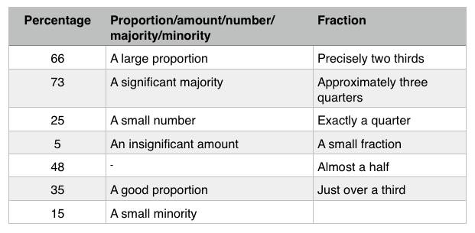

Different ways to describe percentages...Another possible problem is that you find yourself repeating the word “percentage”. Here are some helpful variations for you. There are variations possible in almost every case: using a fraction or a synonym such as proportion.

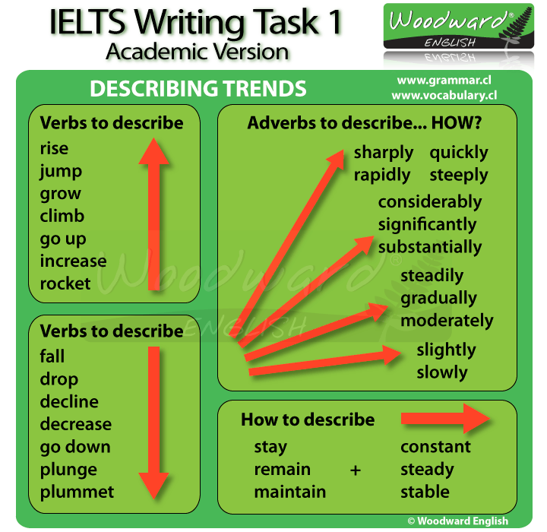

Look at the following graph and read the description.

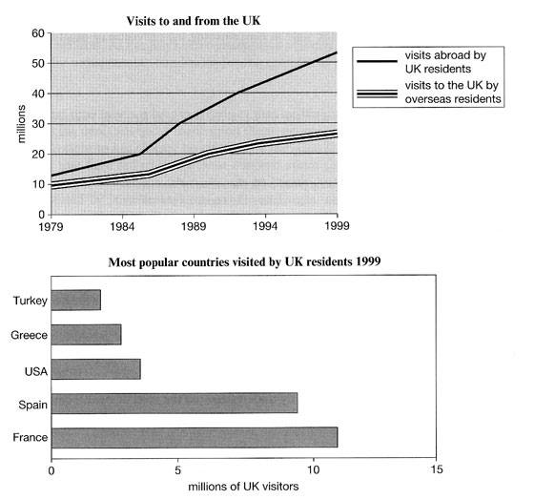[**Siva P**](https://www.facebook.com/siva.p.92?fref=ufi) The graph explains the trend of UK visitors outbound and inbound to UK from 1979 to 1999.As we see , the UK residents visit to abroad was increased drastically from just over 10 million to around 50 million in these 20 years . And, at the same time , the number of visitors to UK has a study increase from 10 million to 30 million. In 1999 , more than 10 million UK residents visited France , which is highest when compared with other countries in the graph.

Li------------------------------------------------------

The line graph elucidates the number of visitors come in England and English people travelled other countries. It is clearly seen that English people travel more than overseas resident. In 1979 more than 10 million English people travelled abroad and swelled significantly year by year and ended up more than 50 millions in 1999. On the other side, overseas people started with 10 million and increased gradually and reached to 28 millions in 1999. Moving on, vertical bar graphs depicts the favorite countries visited by English people. It is clearly observed that first place France more than 10 millions travelled and than Spain and least travel countries were Turkey and Greece less than 5 millions. Therefore, we can say that France is the favorite country for UK residents among other countries.



Write a comment...

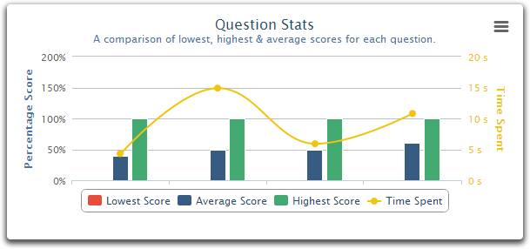

The graph depicts the comparison of lowest, highest and average scores for each questions and its relevant time spent of them. It is quite apparent that there was no lowest score recorded for any question and all the average score for each question has same taken the same amount of time, i.e., around 5 sec , however for highest score the time spent on each question is not more than 10 sec.............Akeel please suggest.

-------------------------------------------

 the picute shows the question statistics which is basically a comparison of lowest, highest nd average scores for each question. We can see that on in order to score average the amount of time spent is 5s or 50%.. and for highest score the amount of time spent is 10s or 100%.. it shows that if someone wants highest score, they must give time and read the question properly

This graph precisely shows that, for first average question takes minimum time around 5 seconds, however, these trends changed from other questions to the average scored questions. Besides, the highest score questions are spent maximum time was 7 Sec and it varies from one to another. In and all, noticeably, shows the lowest scores not spent any time.

This graph shows the comparison of time spend for lowest,average and highest score for 4 different questions. It can be clearly seen that, none of the students scored lowest score for any of the questions and the second question is the most time consuming question among all questions. However, question no 1 and no 3 were not took more than 6 seconds to complete where as highest score students took around 8 seconds to complete question 1. Average score students consumed around 10 secs to complete question 4. In conclusion, it cabe said that question 2 and question 4 are much harder than other two questions.

 The given diagram demonstrates question statistics which compared the lowest, highest and average score in percentage for each question. It is vividly seen that on first question time spent is less than 5 seconds to get an average score, while 10 seconds spent to acquire highest score . Moving on, time spent on question 2 and 3 almost same to obtain average and highest scores i.e. 5 seconds and 10 seconds respectively. Furthermore, on last question more than 5 seconds spent to acquire average score while time spend to get highest score almost same in each question i.e. is 10 second. All in all, we can say that there is no lowest score among all questions and time spend to obtain highest score is same in all questions.

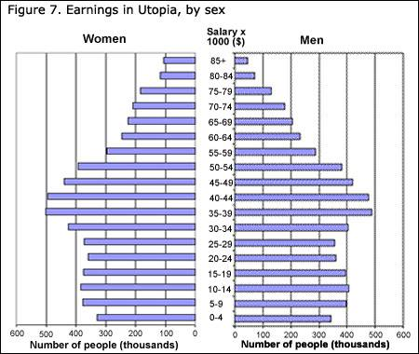

The graph shows the earning in utopia with respect to the number of poeple.. we can see that most men and women which is around half a million each earn somewhere around 39 to 44K USD. Surprisingly, a huge number of people which is around 325,000 men and women earn around 0-4K, which shows the staggering unemployment and low income rate. On the other hand, around 300,000 men and women earn over 60K and this number of people starts to decrease with the increase of salary and reaches somewhere equals or less than100,000 with repsect to the salary 85K. In the higher salary group women consist of a slightly higher number than men.

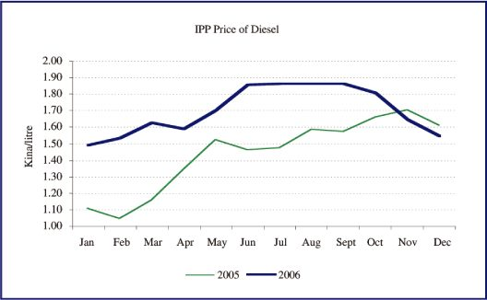

The presented graph illustrates the annual fluctuation in the IPP price of diesel in the two comparative years 2005 & 2006. Its evidential from the spikes that prices went up in May in 2005 and in June in 2006. The prices continued to rise and increase till November in 2005 and post that there is a decline in december. in 2006 prices remain steady from June to September and then gradually prices gadually keep declining till the end of the year.

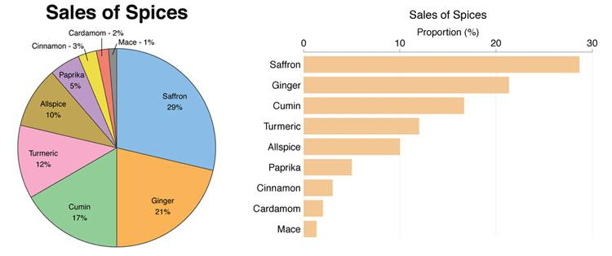

he pie chart illustrates the salience of sales of various kind of spices. It's pretty much clear that Saffron contributed the highest sales mix followed by ginger cumin and turmeric. Mace, Cardamom, Cinnamon & Paprika contributed the lowest

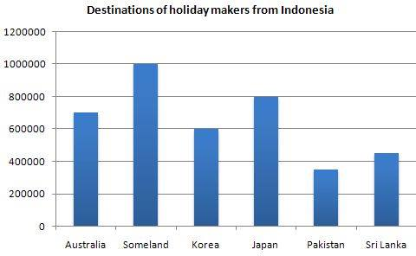

The bar graph depicts the holiday destinations preferred by Indonesians. The no.1 destination was Someland by 10 million Indonesias and this is followed by Japan (8 million), Australia (seven hundred thousand), Korea (six hundred thousand) , Sri Lanka(slightly above four hundred thousand) and lastly, Pakisatan(slightly below four hundred thousand). Overall, Indonesia holiday makers give top preference to Someland and least preference to Pakistan.

The bar graph illustrates the various holiday destinations preferred by Indonesians. It is of note that the Someland was the most popular with 1 million giving preference, followed by Japan at precisely 0.8 million. Moving on to Australia approximately 0.7 million Indonesians visited, whereas Korea stood for 0.6 million. Finally Srilanka nd Pakistan was the least preferred with just over and just under 0.4 million respectively. To sum up, I will say that Indonesians gave the most preference to Someland and the least to PAkistan

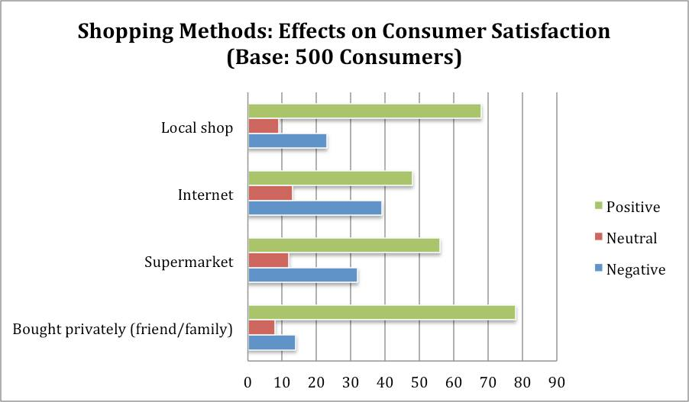

This horizontal bar graph depicts various shopping methods which are effect the satisfaction of consumers. The survey is done with a customer base of 500.The Vertical axis displays the various shopping methods like local shop, internet, supermarket and private shopping used by consumers. As per records displayed, percenatge of neutral consumers is amlost same in all methods, where has percentage of consumers who are positvely effected can be seen in private shopping methods.

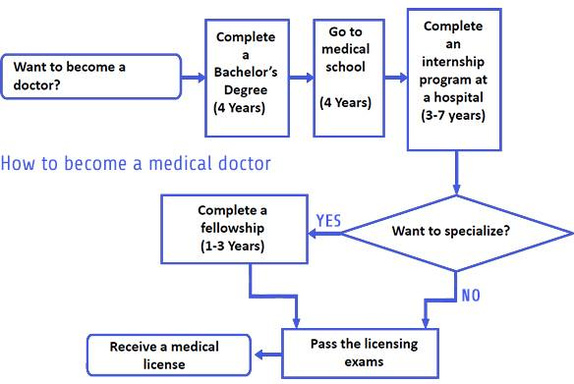

 The flow chart illustrate the process on how a person could become a doctor. First a person will have to complete a 4 year bachelor's degree followed by 4 years in medical school. After which they will have to take part in an internship program for a period of 3-7 year. After a completing the internship program if a person doesn't want to specialize they could direct sit for the licensing exam but if they want to specialize they will have to complete a fellowship for 1-3 years and then take the licensing exams. The final step is to receive the medical license.

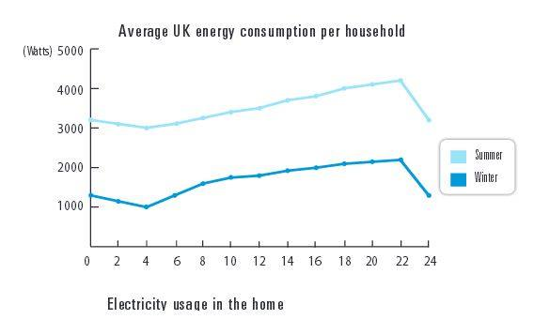

The line graph represents the average energy consumption per household in the UK. It can clearly be seen that during first 4 hours britains consumed less amount of electricity in summer and winter. On the other hand, as time passed the electricity consumption rose gradually in both the seasons until during night they used less electricity. To sum up,the average consumption per household was the highest in summer and used less amount in winter.

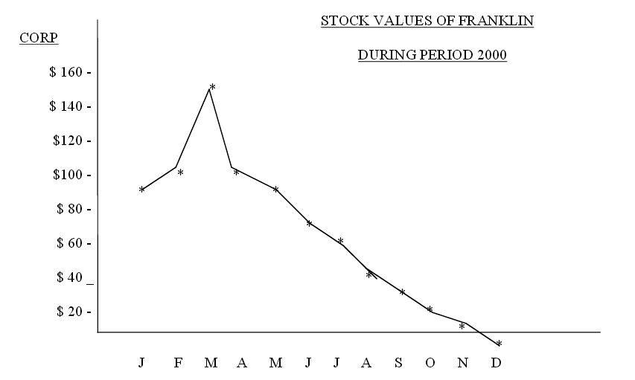

The line graph illustrates the share prices of Franklin in dollars for a period of 12 months in 2000. It is immediately evident that in January the share price was nearly $90 and reached a peak of around $150 in March. However, thereafter the share prices consistently plummeted and by December the share prices were at negative level. To conclude, generally the Franklin stock values showed a decreasing trend over a 1 year time frame.

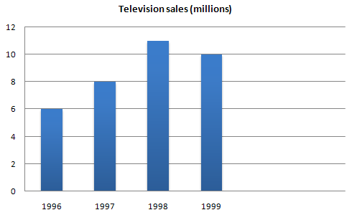

#### In this graph of Electro Inc’s television sales between 1996 and 1999, we can see that purchases of televisions went up in 1996 and continued to rise steadily until

#### 1998 when they dropped slight. Up variations

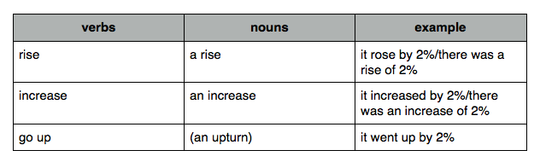

**Down variations**

[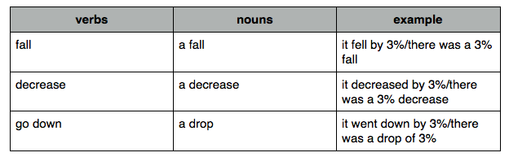](http://www.dcielts.com/ielts-writing/task-1-graph-vocabulary-1/attachment/fall-vocab-2/)

**Up and down**

Sometimes you need to describe a graph that goes up and then down. Here we have fewer options.

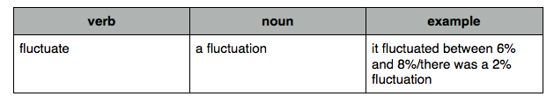

**No change**

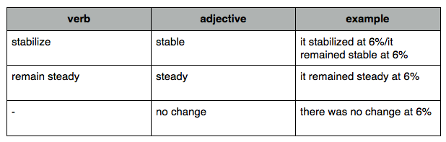

**Top**

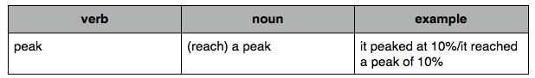

**Preposition problem 1 – by and to**

Prepositions are horrid in English. Have another look at the graph:

[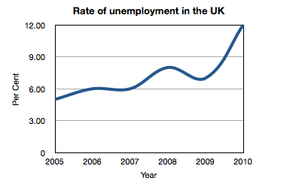](http://www.dcielts.com/ielts-writing/task-1-graph-vocabulary-1/attachment/simple-line-graph/)Note how these two sentences mean exactly the same:

The rate of unemployment rose to 12% in 2010.

The rate of unemployment rose by 5% in 2010.

DESCRIBE IMAGES TACTS   
1- PIE CHART –  
This is a pie chart that shows ……….  
Maximum part or lion share part or prodigious is covered by …….  
Modicum or least part is covered by ……..  
There is a slight gap between……  
On the whole …..  
2- Line graph –  
This is a line graph that shows ……  
Peak point is in the ………..  
Ground level is in ………..  
It is in fluctuating or zig zag motion ..  
On the whole ……..  
3- BAR GRAPH –THIS BAR GRAPH DEPICTS INFORMATION ABOUT ……  
Maximum part is covered by ….  
Minimum part is covered by   
It is in increasing or decreasing trends ….  
On the whole , it is palpable …………  
4- WORDS THAT CAN BE USED in images –  
5- a--Start- Shows , depicts , throws light on ,illustrates , illucidates ,   
b---Maximum – major , prodigious , lion share part   
c---Minimum- minor , least . modicum  
d-Changes – slight , gradual , steady , suddenly, sharp  
e---Movement up- increased, rose , grew , went up ,incline , upsurge , burgeoning ,   
f---Movement down –decreased, declined , drooped , went down   
g---Large increase- boost up  
h--- FAST decreased- plummet   
i---Structure – foreground , background , in the upper part , in the lower part ,behind , next to , on the right , on the left , above , below   
j---no movement – remained steady , stable , unchanged , stabilized  
k---preposition – from , between

Words for use in images

1. For start- shows , depicts , illustrates , represents , elucidates , throws light on
2. Maximum- lion share part , major , prodigious , paramount supreme, topmost
3. Minimum- least, modicum , merest , slightest , smallest
4. Average- moderate , mediocre , middle of the road , intermediate
5. Increasing-booming , enlarging , up surging , burgeoning , inclining , sprouting
6. Decreasing – sink , decline , diminish , curb , deteriorate
7. Constant- uniform , regular , stable , steady . unfluctuating , unflappable
8. Fluctuating-oscilate , wary . , sling , yoyo , hem and haw
9. Peak- pinnacle , tip , crown , bump
10. Ground level- sod , loam , dust , arena
11. Conclusion – to wrap , end of the line

How to Describe Image in PTE Academic Test of English

The purpose of this task is to assess your ability to describe an image related to an academic theme drawn from the humanities, natural sciences, or social sciences. Only speaking skills are assessed. You will see an image (a graph, picture, map, chart, or table). You will have 25 seconds to study the image. When you hear the tone, you should begin describing in detail what is shown in the image. You will have 40 seconds to give your response. There are six or seven images.  
Identify the type of image. Is it a graph, picture, map, chart, or table? The approach for handling each image type is slightly different.

• Take notes if you need to. Use the Erasable Note board Booklet and pen provided. Do not write full sentences; briefly list any important features you see.• For graphs, charts, and tables, be sure you understand what is being measured and in what units it is being reported.

• Try to determine what the main point of the image is. You should be able to answer the question, "What is the image mainly showing?"

• Maps and pictures will often have obvious features highlighted. Use words and phrases that describe the locations of features within the image, for example, on the leftj right, next to, above, below, and so on. If objects are particular colors, these may help you identify them, for example, the countries marked in yellow. The same is true for sizes and shapes, for example, the large square, the smaller circle.

• Graphs, charts, and tables often show trends or changes. Use words and phrases that describe the trend or movement. For example, increase, decrease, rise, fall, remain stable/steady, and so on. Use phrases to describe the speed at which the changes happen, for example, a sudden increase, a slow decline.

• Pie charts show proportions. The size of the "slices" indicates the relative size of whatever is being measured or counted. The actual numerical values for the slices are usually provided. Be sure to mention these values. If the slices are equally sized, say so, using words and phrases such as equal, the same, about the same, similar. If the slices are different - the usual case- use comparatives and superlatives to describe them, for example, the smaller of the two export categories, the largest group of people, the most popular option, the least common answer, and so on.

• For all graphs, charts, and tables, look for a pair of extreme values - for example, the highest and lowest, the largest and smallest, the most expensive and cheapest - identify them by name and describe them using the values for their measures or counts

.• While you are speaking, if you lose your train of thought, or find yourself at a loss for words, do not remain silent. The microphone turns off automatically if there is no sound for three seconds. lf you need to pause to think or check your notes, use pause fillers such as um, uh, Let me see, and so on. Saying something - anything - is better than saying nothing because once the microphone turns off, you cannot turn it on again.

Source: Internet (I will Share my notes Asap) for the time read and follow

Describe image:

This section is tricky and challenging as we have too much information to comprehend in a short span of time (35-40 sec) before you start speaking. Try to speak about most of the information from the image in an organized manner than sharing (all/most of) the information in an unorganized manner. We get maps, graphs (bar graphs; pie-chart; trend graphs.Maps,images etc). We get around 6-8 questions in this section.

Interesting and really helpful in speaking Describe Image

Introducing the topic

• The graph shows… / The table reveals…  
• The chart displays… / The diagram illustrates…  
• Some interesting facts concerning… are revealed in the diagram.  
• Several key trends are revealed by the graph showing…

Introducing the first set of data

• Beginning with the…  
• To begin with the…  
• Let me begin by describing the…

Introducing the second set of data

• Meanwhile, the… shows that…  
• As for the… , it shows that…  
• Turning to the… , it can be seen that…

Introducing the first major trend

• First of all, it is clear that…  
• Most noticeably of all, it can be seen that…  
• The first result worth pointing out is that…

Introducing lesser trends

• Another trend that can be observed is that…  
• It is also worth pointing out that…  
• Also worth noting is that…

Exceptions to the main trend

• However, this was not always the case.  
• However, it should be pointed out that…  
• There was one noticeable exception, however.

Comparing and contrasting

• Similarly, … / By contrast, …  
• A similar trend can be observed in…  
• The results for… , however, reveal a markedly different trend.

Adding figures

• The figures were X and Y respectively.  
• …, at X. / …, with Y. (Usage note: use ‘at’ when you mean ‘the figure was'; use ‘with’ when you mean ‘something had’)  
• …, at/with X and Y respectively.

Concluding and summarising

• To sum up, … / In summary, … / In short, …  
• Overall, … / On the whole, …  
• The main thing that can be observed here is that…

I HOPE THIS WILL HELP YOU ALL

Connective words for describe image : You can use these words in describe image

The graph shows..  
The graph represents..  
As can be seen from the graph,   
As indicated by the graph,

However,   
In contrast,   
In comparison,   
After, before, until

In sum,   
To sum up,  
In concluding,  
In conclusion,  
From the graph it can be safely concluded that  
We are safe in concluding that

Tips for Describe image:   
1. This item is having second highest weight-age after re-tell lecture. So focus on this, to achieve good scores in Speaking module.  
2. There are 6 to 7 different types of things u will get for this item type. Like describe bar-graph, line-graph, pie-chart, block-diagram, table, photo, picture.  
3. You will get around 6 to 8 items. Including all different types of images as cited above.  
4. You Need to use different vocabulary words in this. For example you need to follow below phrases to describe-  
This bar-graph depicts the Australia population for 1950 to 2000. It noticeably showed from 1950 to 1970 the growth of people is steady. However, from 1970 to 1990 it fell down and touched the lowest value at 35 Billions.All in all / at last, it can be seen that it reached the maximum value at 56 Billions.  
Other starting phrases are: This pie-chart illustrates...........  
This block diagram shows ...............  
This picture / photo demonstrates...............  
This line-graph denotes...........  
5. Do not use much pillar words like (hmmmm, uhhh, etc) and not take long pauses.  
6. Try to speak full time (40 seconds)   
7. Content is not much important,, however it also one of the important factor. Main focus should be on pronunciation and oral fluency. Do not follow any separate pronunciation , use neutral pronunciation>  
8.Try to identify main/key/essential points given in the diagram and describe those points.

For graphs, pie charts and images

1. The line graph represents/illustrates  
2. It is immediately evident/ apparent. We can clearly see that  
3. Next, Finally, Lastly, Firstly, Secondly, with, therafter.  
4. Whereas, While, Although, but.  
5. Up words- Rise, increase, soar, rocketed, climb, surge  
6. Down words- fall, decrease, plummeted, down, dip  
7. Uncountable nouns and countable nouns

For graphs

East, West, North and South  
Left, right, across, over, under

Few more collocation:-  
Heavily armed,Seriously injured, seriously damaged,  
Strictly:-  
speaking, true, regulated,limited  
Potentially:-  
Dangerous, Fatal, Hazardous, at fault/ to blame  
Blantantly:-  
unfair, untrue, dishonest,wrong,mistaken.  
Astronomically:-  
High/low , Large, Expensive, Immense

Some More Vocabulary for Describing graphs=  
Going Up==== rose ,increased ,went up, grew  
Going Down==decreased,fell,dropped,declined  
No Change==stayed the same,remained constant,levelled off,stabilised  
Up and Down==fluctuated,zig-zagged,fluttered,undulated  
Small Changes - Adjectives / Adverbs==gently,gradually,slightly,steadily  
Big Changes =Adverbs /Adjectives==suddenly,sharply,dramatically,steeply  
a lot  
Low Points==bottomed out, reached a low

For Guys who are facing hard time in describe image and retell lecture=

Practice is the Key. For describing an image. You should memorize the start up words like:  
This graph shows -----  
This picture shows ----  
This image reflects ----  
Keep in mind you just have to tell the key points of the image/picture/graph, NOT everything, because time is short. It will be like 2 steps:  
Tell about the main purpose/title of the image. Then Key points only. You will be scored on all this. You can even, during Practice prepare and memorize the main Script having fill in the blanks. This main script should be developed like you are a teacher in a classroom and you have to teach about an image in 3 minutes. The main problem is flow of words while looking at the image. So if u are already trained to speak out quickly these words such as, increasing, declining, trend, development, growth, margins, profits, loss etc then it will be easy for you to speak in flow while describing everything or most of the things in an image.

Describe image:  
Please understand that we are not expected to explain the whole graph in 40 secs. It is highly impossible. They check whether our speech is naturally flowing and are we able to convey the information effectively. Here slow and steady wins the race. We should be clearly speaking with optimal pace. Never rush to tell all the information. This might penalize you on pronunciation, meaning computer might not be able to correctly capture all your words.   
1. Introduction:  
-The graph shows/displays the number of ITunes songs bought …,   
-In this graph, we can see the number of ITunes songs purchased …,  
-The photo/image shows a (scene, buildings, place) from a distance

2. Body:  
-The information indicates..., From the chart/graph..., We can conclude that...

** You should include an introduction, a main body and a conclusion in your description  
**If you lack points to speak, speaking something like, “It is really interesting to know this information” or something of this sort.

Frequently Misspelled Words:--  
Absence ,address, advice , all, right , arctic ,beginning, believe , bicycle, broccoli ,bureau calendar , camaraderie ,ceiling, cemetery, changeable, conscientious , conscious decease , deceive ,definite, descent , desperate ,device , disastrous, ecstasy , embarrass, exercise , fascinate , February, fiery ,fluorescent, foreign, government , grateful , guarantee, harass, height, humorous ,independent, jealous ,jewelry ,judgment ketchup ,knowledge, leisure ,library, license, maintenance, mathematics, mediocre millennium, miniature, miscellaneous, mischievous, misspell, mysterious, necessary neighbor, nuclear ,occasion ,occurrence, odyssey, piece ,pigeon ,playwright, precede prejudice, privilege ,pumpkin, raspberry, receive, rhythm, sacrilegious, science ,scissors separate, sincerely ,special, thorough ,through ,truly ,until ,Wednesday , weird

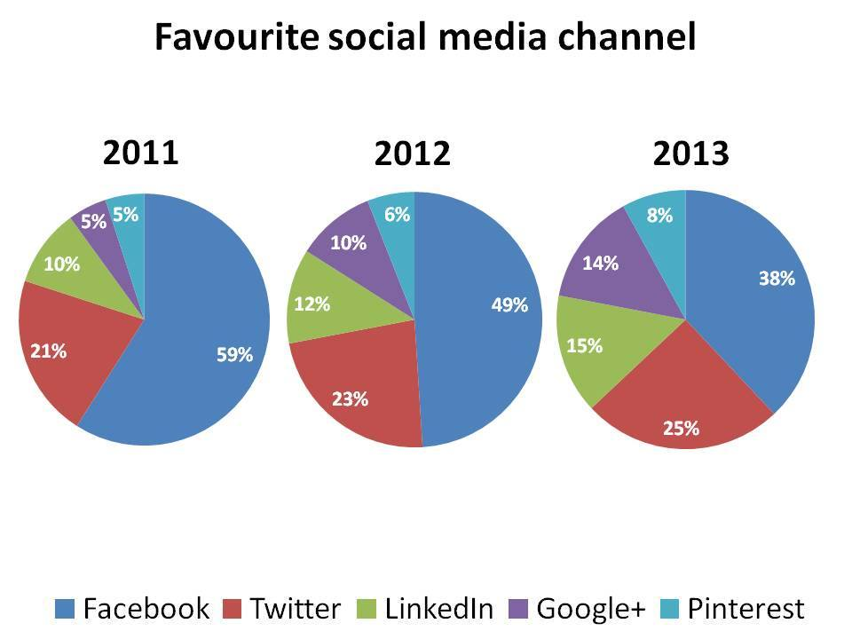

The three pie chart shows the most popular social media channel between 2011 and 2013.It is immediately apparent that facebook was the most favourite social media channel, but its popularity declined over the time frame. On the other hand twitter and linkedin showd a similar increasing trend and stood between15 and 25 percent. Finally a small proportion of google plus and p interest was viewed. To conclude Google was the most favourite, while pinterest was least browsed.

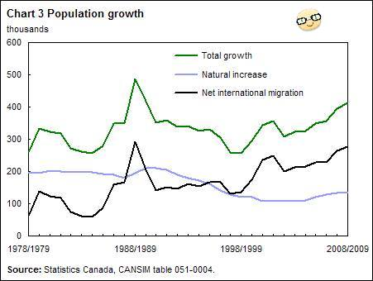

********** Describe Image Speaking Module************  
Use of Tenses  
Mind the correct use of tenses when describung a chart. If the charts deals with facts in the present , use the Simple Present, if the facts are the past, then use the Simple Past. If there is a connection between the past and the present, use the Present Perfect.

How to describe a chart  
With the following example we would like to show you how charts are described. Mind the three parts and do not repeat the global message in the conclusion.

This graph shows the growth of the population in Canada from 1978 to 2009. It is taken from the website about Statistics in Canada.  
There are three graphs in the chart. The green graph shows the total growth of the population, the black one deals with the migrated people in Canada and the blue graph shows the natural increase of the population. In 1988/89 there was an enourmous growth. In the following years the total growth went down to about 250,000 in 1998/99. From that time on the Canadian population has been gradually growing again although the natural increase slows down. So we can say that the growth of the population in Canada is based on migration.

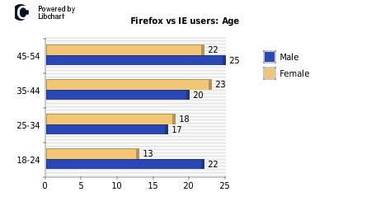

The given bar graph illustrates number of male and female users with certain age using internet explorers ie IE and firefox.  
The top horizontal bar shows that out of 45 firefox users and 54 IE users, female users are 22 years old and male users are 25 years old.  
The 2nd bar from top shows out of 35 firefox users and 44 IE users, male users are 20 years old and female users are 23 years old.  
The 3rd bar from top indicates that out of 25 firefox users and 34 IE users, male and female users belong to same age group ie 17 years and 18 years respectively.  
The bottom horizontal bar shows that males and females of age 22 years and 13 years respectively belong to the group of 18 firefox and 24 IE users.

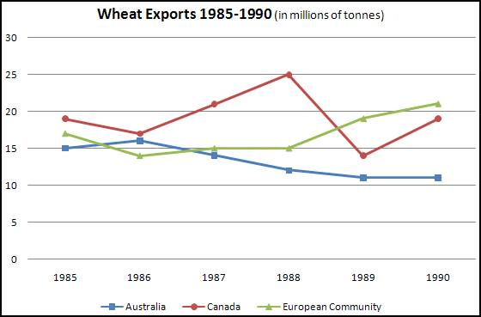

The Line graphs compares different countries in terms of amount of wheat they exported from the year 1985 to 1990. It is lucid that Canada exported approx 19 million tonnes of wheat in the year 1985 and reaches its zenith value 25 million tonnes in the year 1988. On the other hand Australia lags behind in exporting wheat ..Australia started with 15 million tonnes in 1985 and ended with 11 million tonnes in the year 2000

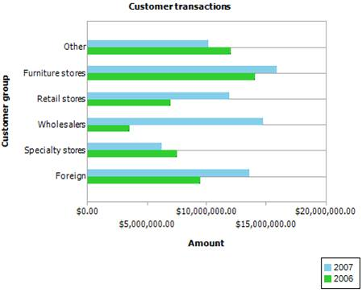

The bar graph compares transactions from different sources between 2006 and 2007. It is immediately aperients that major transactions contributed from furniture stores in 2007. In the same way 14 million dollars transactions from furniture stores 2006.

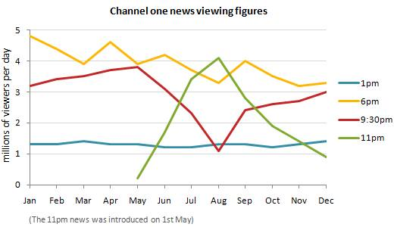

These line graphs illustrate the number of viewers per day for channel one news over a one year period. It is immediately apparent that from januery to April there was three news hours per day which starts at 1PM, 6PM and 9PM. In the month of May they introduced 11PM news. To began with. In January 6PM news had 5 million views per day

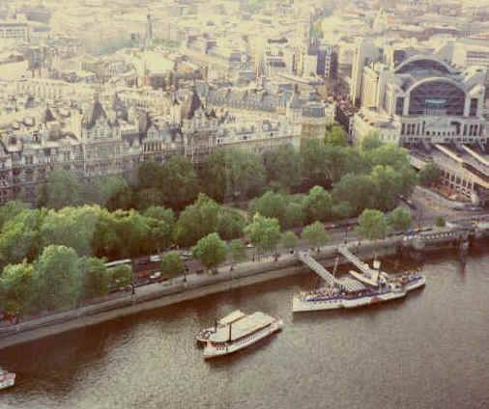

1. The above image is one of the city which is located near river. There are 2 ships which I guess used by inhabitants of that city for enjoyment and take a wonderful view of entire city. Next to the river there are plenty of trees with a main road connecting to the other side of the town. Finally there are some buildings which I feel that it is used for commercial purposes.
2. The given image shows a part of a portal city . Though the background of the picture is not clear but it can be easily guessed that the background is covered with multi-storeyed buildings which are very conjusted. It denotes that the city is densely populated. In the foreground picture, the roads are beautifully constructed along the sea shore. The trees which are planted on either sides of the road enhance the beauty of the city. It looks as if there are few small ships and engine boats are kept for public amusement .
3. It’s an aerial view of a developed city. In the foreground there is a river and there are some boats and a cruise so it’s a pertinent place from tourist point view, and road is circumference with lot of greenery. Furthermore, in the background there are skyscrapers. All in all, city having a significant place in the growth of economy.

Helpful words and phrases for describing graphs:-  
UP – Verbs rise, increase, grow, go up, improve, jump, surge, shoot up , soar, rocket  
UP – Nouns a rise, an increase, growth, an upward/rising/increasing trend, an improvement, a jump, a surge  
DOWN – Verbs fall, decrease, drop, decline, go down, slump, plummet  
DOWN – Nouns a fall, a decrease, a decline, a downward/falling/decreasing trend, a slump  
NO CHANGE: – Verbs remain stable/constant, stay at the same level, stabilize  
FREQUENT CHANGE – Verb fluctuate  
FREQUENT CHANGE – Noun – fluctuation  
AT THE TOP – Verbs reach a peak, peak., reach its/their highest point  
AT THE BOTTOM – Verbs reach/hit a low (point), hit/reach its/their lowest point  
CHANGE:-   
Adjectives:  
dramatic, considerable, sharp, significant, moderate, slight, sudden, rapid, steady, gradual, slow  
Adverbs:  
dramatically, considerably, sharply, significantly, moderately, slightly, suddenly, rapidly, steadily, gradually, slowly

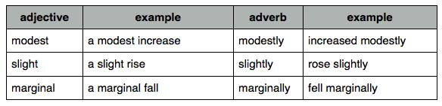

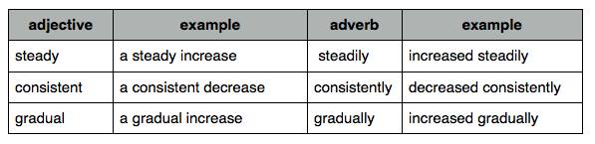

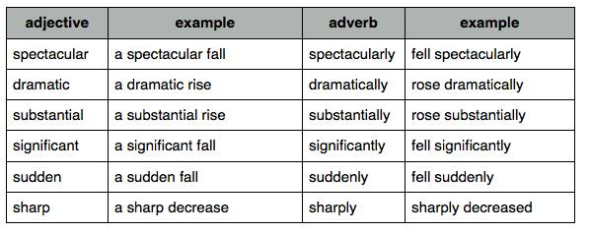

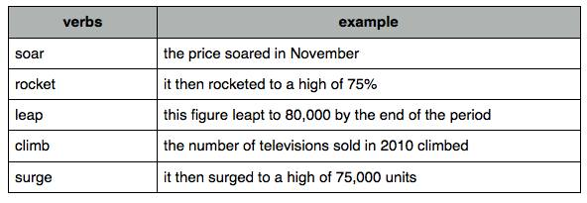

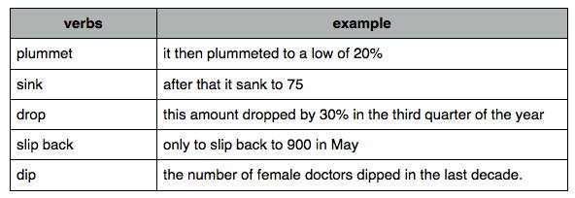

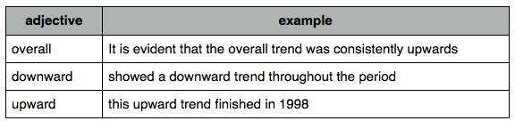

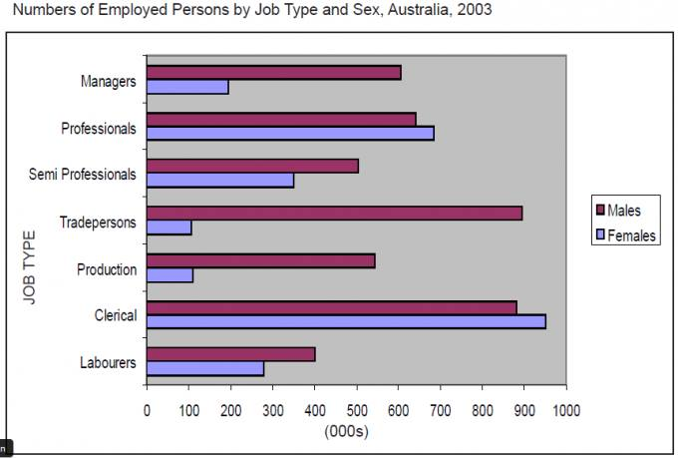

The bar chart illustrates the number of men and women employed in six positions in Australia in 2003. It is immediately evident that generally more number of males than females were employed, and that tradepersons stood the highest for males and clerical for males over this time frame. To begin with males, around 900 worked in tradepersons and clerical positions with approximately 600 worked in managers and professions. Finally, semi professionals, production and labourers positions stood in the range of between 400-500. Moving on to females the situation was totally different. 900 females worked in clerical psoitions, this figure was dropped to atleast a half in professionals category, which was much more ahead of men. Next, semieprofessionals, labourers and managers positions for females were in the range of 200-300, but lesser than males. Finally, only one in ten women worked in tradepersons and production.

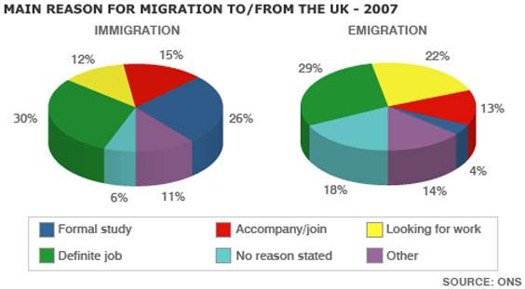

The pie chart illustrates the main reasons that people migrated and emigrated to the UK in 2007. We can clearly see from the pie chart that the definite job and searching for work accounted for the largest proportion of emigration and migration  
  
To begin nearly one third of people went and left the UK for definite job, while one fifth of people emigrated for job search, only just over one in ten people immigrated for this purpose.Next just over a quarter of people immigrated to the UK for formal study, but this figure was only 4% for emigration.

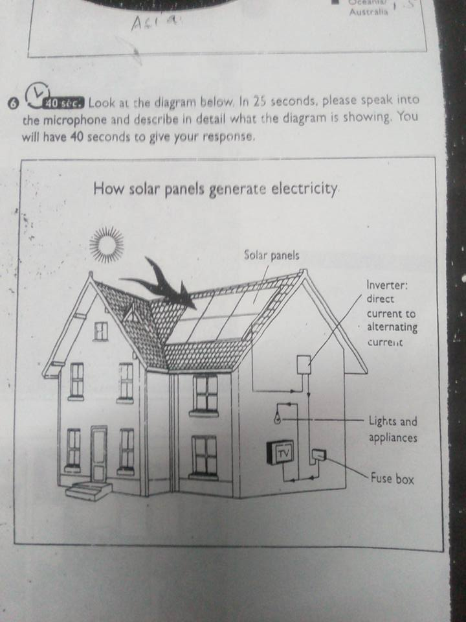

 The illustrated image shows us the process of conversion of solar energy into electricity. The sun rays fall on the solar panels fitted on roof top. The direct current is inverted into alternate current which passes on to our house hold appliances via fuse box.

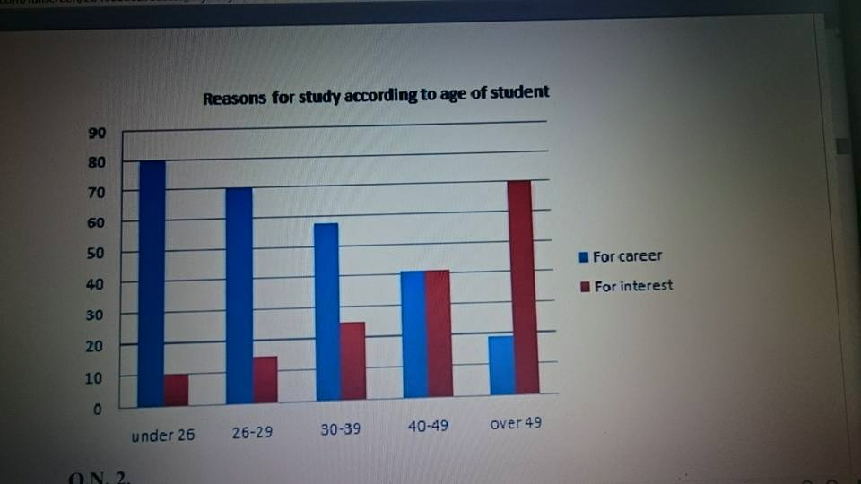

[**Akshay Narang**](https://www.facebook.com/akshaynarang94?fref=ufi) the graph shows the number of students studying with perspective of interest and career . As we can see,students under the age of 26 study with career objective with about 80 students and 20 with interest and the situation takes a different route with the increase of age and the number of students with interest increases with about 70 students and 28 with career

[**Michelle Verhoeven**](https://www.facebook.com/michelle.verhoeven?fref=ufi) The bar graph depicts the direct correlation between age and the reason for studying. Students under the age of 26 studied for a particular career as opposed to students over the age of 49 who studied for interest.

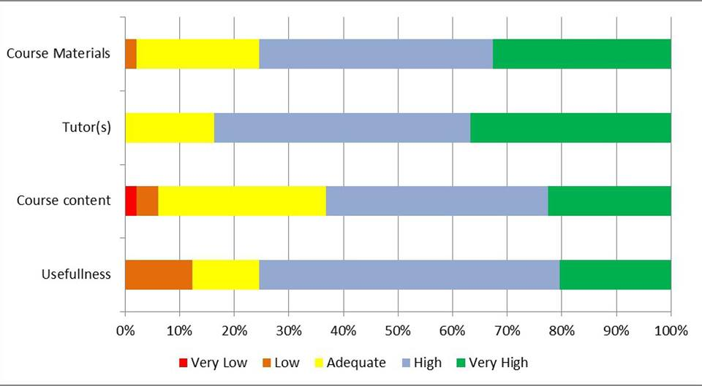

How to explain lengthy graphs [‪#‎PTELOGIC‬](https://www.facebook.com/hashtag/ptelogic?source=feed_text&story_id=482924288545990)

Graph Tips

If you ever get struck while explaining any such you don't need panic as the situations can become worst after that you just need to speak whatsoever you are understanding in the graph.

The graph which carries a lot of information in that, you need to explain the overview of it. There is no need to explain each and every detail mentioned in the graph .You should focus on the striking features or the things which can be distinguished easily.As in this graph, the thing which can be easily noticed is the tutor's part as it do not carry any negative rating.

To make your command over the describe image section, in the initial practice stage, you should explain the graph as much as you can, no matter if it crosses the 40 sec.The maximum you will learn to explain any graph will help you to speak continuously for 40 sec in your final exam.After practicing for few days, you can reduce the timing to 40 sec.

Here are the few lines to describe this graph.

The horizontal bar graph demonstrate that the participants have given the tutors the maximum positive rating as for them the rating starts from adequate margin Whereas, rating for other three courses that are course material, course terms and usefulness starts from the very low and low in which maximum negative rating is given to the usefulness of the course.

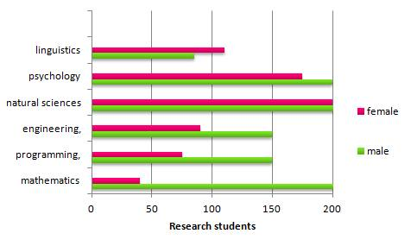

The chart shows the enrollment comparison of 400 research students with equal number of males and females. All the students opted for Natural Sciences. Psychology and Mathematics were opted by all male students with comparatively lesser female enrollments, similarly Engineering and Programming received around 75%,of male enrollments and less than 50% female enrollments. Linguistics opted by a bit more than 100 female students and near about 85 male students.



The pie chart illustrates the main reasons that people migrated and emigrated to the UK in 2007. We can clearly see from the pie chart that the definite job and searching for work accounted for the largest proportion of emigration and migration  
  
To begin nearly one third of people went and left the UK for definite job, while one fifth of people emigrated for job search, only just over one in ten people immigrated for this purpose.Next just over a quarter of people immigrated to the UK for formal study, but this figure was only 4% for emigration.

Top of Form

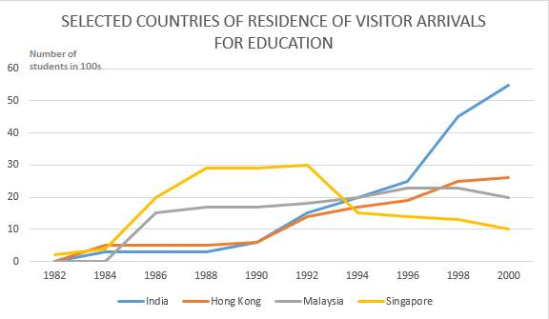

The depict line graph illustrates the relationship of Number of students which is in 100s with different years (from 1982 to 2000) of prominent Asian countries who visit for the purpose of education. To begin, dramatic increase is noticed on the indian visitors while significant drop is noticed from the visitiors of Singapore however Hongkong and Malaysia are levelled off. Overall, Indian visitor showed substntial growth and Singapore dropped off drastically.

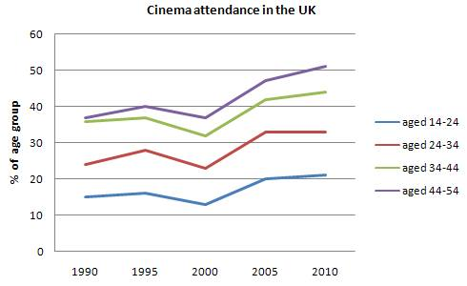

The depict line graph illustrates the relationship of different age groups which is in percentage with the years during 1990 to 2010 of the attendees in the UK cinema. To begin, age between 14 to 34 rose sharply between the period of 2000 and 2010. However, dramatic increase is noticed between the age of 34 to 54 during the years 2000-05 and then levelled off. All in all, one can conclude that a substantial growth between 2000 and 2005 of different age groups

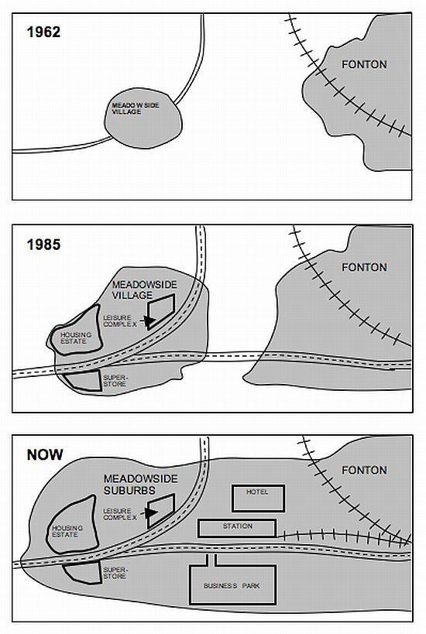

The given three pictures shows the considerable amount of development in fontan and meadowside village. As learnt, technology and globalization had played a vital role to connect either of them to other distant cities and also transformed them to business and urban estates.

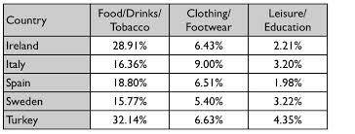

The provided table demonstrates the expenditure on three major categories by various countries. It is obvious from the figures that most of the countries's expenditure revolves around food, drinks and tobacco, therefore, Turkey spends 32% and Ireland with 28% are leading the chart. Secondly, cloths and footwear places as a second major category, where Italy's expenditure is touching at 9% outrages other countries. Finally, leisure/education type is grabbed by turkey with 4% as compare to Spain at 2%. [Amrit Pai](https://www.facebook.com/amrit.pai?hc_location=ufi) rooprai [Rooprai Gaurav](https://www.facebook.com/grooprai159?fref=photo&hc_location=ufi) please review.



The bar chart illustrates the number of men and women employed in six positions in Australia in 2003. It is immediately evident that generally more number of males than females were employed, and that tradepersons stood the highest for males and clerical for males over this time frame. To begin with males, around 900 worked in tradepersons and clerical positions with approximately 600 worked in managers and professions. Finally, semi professionals, production and labourers positions stood in the range of between 400-500. Moving on to females the situation was totally different. 900 females worked in clerical psoitions, this figure was dropped to atleast a half in professionals category, which was much more ahead of men. Next, semieprofessionals, labourers and managers positions for females were in the range of 200-300, but lesser than males. Finally, only one in ten women worked in tradepersons and production.

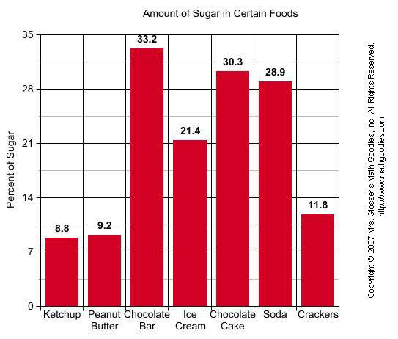

The bar graph illustrates the levels of sugars in seven various types of foods. It is immediately apparent that the chocolate bar contains maximum levels of sugars, while ketchup accounted for the least  
  
To begin, just over one third of sugar is present in chocolate bar, closely followed by chocolate cake and soda at just over and just under a third respectively. Approximately one fifth sugar is present in iccream, while crackers contain only approximately one out of ten. Finally, the sugar levels in ketchup and butter accounts for in the range of nearly 9%

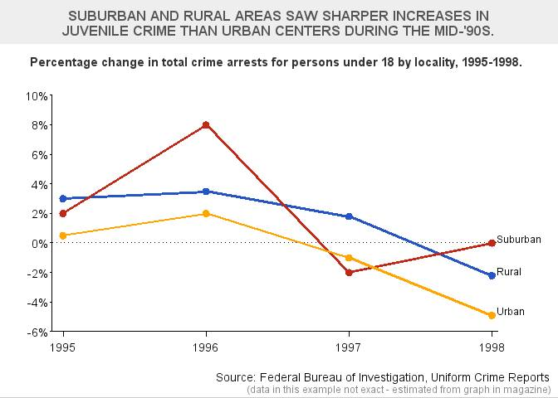

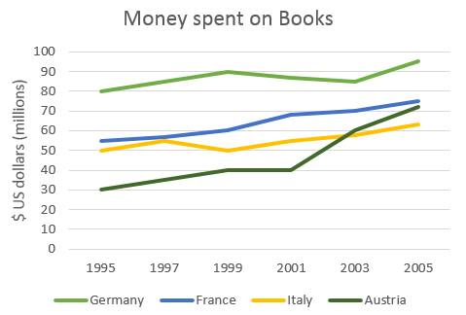

 The above stated line graph illustrates the relationship of sales which is in US dollars with ten years period of different European countries over the spending on books. To begin, steady growth is observed in france, Italy and Austria during 1995 till 2005. However, in the initial period Germany dipped but later on Germany is the country who spends significant money on the books year by year. Overall, Germany is leading the spending as compare with rest of the countries.

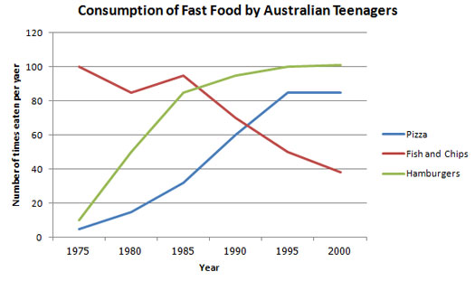

The line graph illustrates the consumption of three types of fast food by Australian teenagers. Although the consumption of fish and chips were the highest in 1975, there was significant drop to 38 times in the year 2000. In contrast, consumption of hamburgers grew by almost 90 times during this period. Finally, pizza was the lowest consumed fast foot but after the year 1991 it is the second highest consumed fast food standing at 83 times year during the past 10 years.

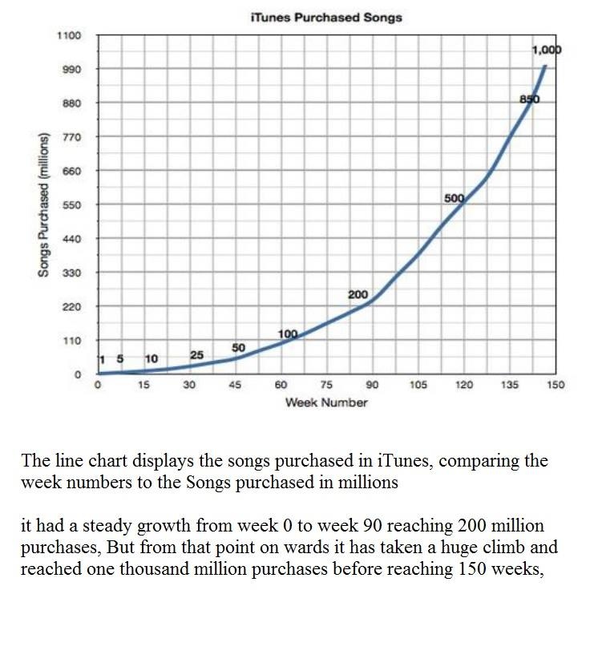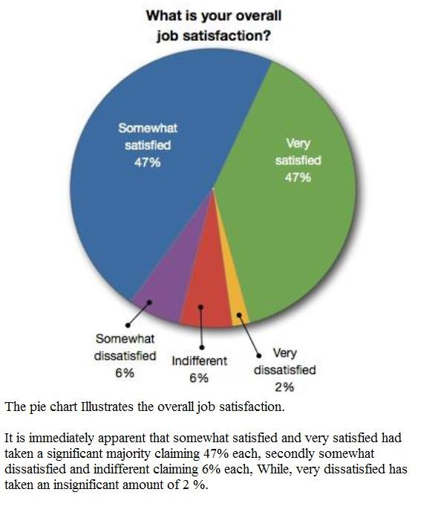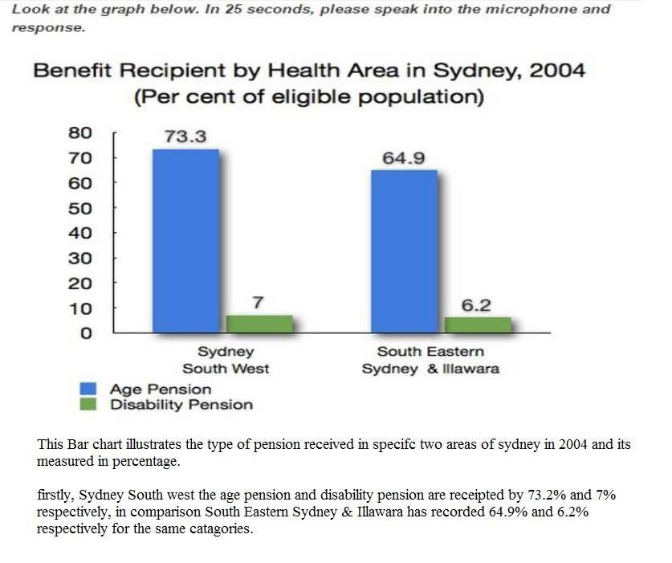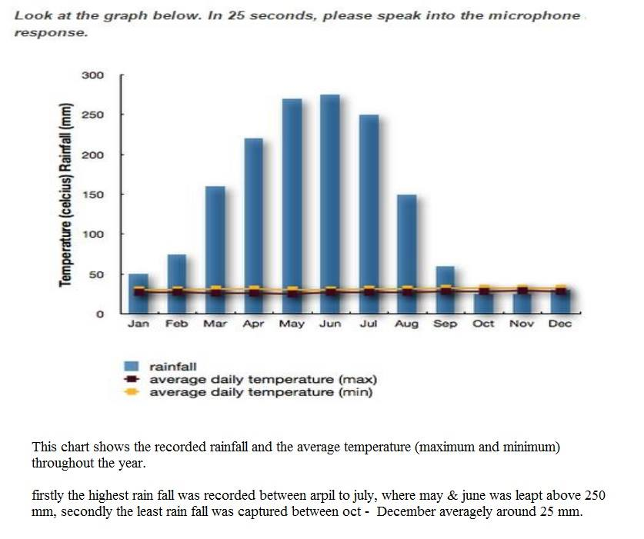

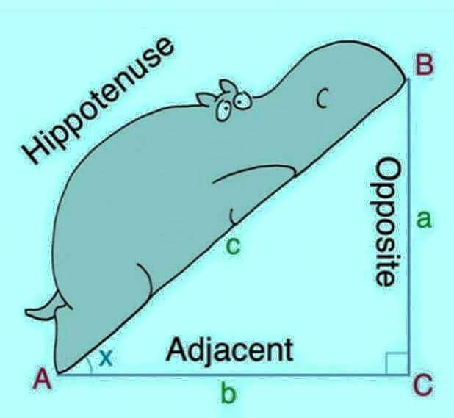

The presented picture illustrates a right angle triangle. The base is named as the adjacent represented as small case b, the elevation has been names small case a and the hypotenuse has been names as small case c. There is also a picture of a 'funny' looking hippopotamus leaning on the hypotenuse probably for the purpose of memorizing the position of hypotenuse.

This picture demonstrates the ABC right angle triangle, in which a represents opposite side  and b represents adjacent side of angle  X angle. And C denotes hippotenuse or hypotenuse.  The picture of hippopotamus placed on the hypotenuse to remember the hypotenuse.

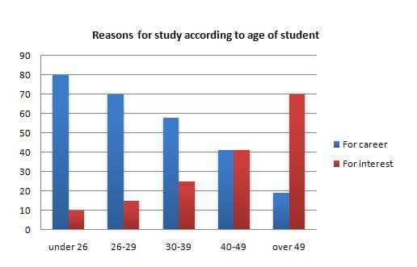

This bar chart illustrates the comparison between the students age and the reason for the studies, It is clearly seen that 80% of the students who are under 26 studies due to their career, and it started decreasing and reached less than 20% with age over 49.

As of for Interest it is seen that under 26 had started with 10% and ended with 70% with over 49, Overall it’s clear that when the students grow on age, the reason is changing from Career to Interest....

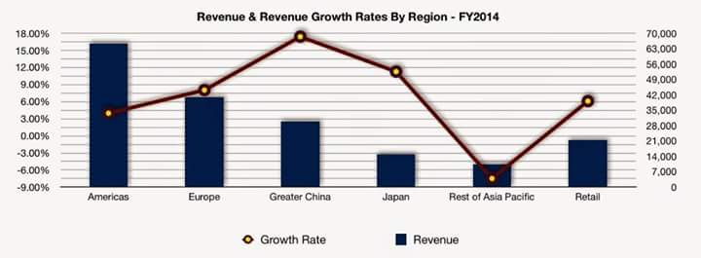

The given bar illustration depicts the revenue and line shows revenue growth rate in particular 6 countries in 2014.It is crystal clear that Greater degree of revenue comes from America, accounted for 16%, following by Europe with almost half of America's revenue. Moreover other remaining countries revenue  was below 3%.

As for as revenue growth rate is consirned Greater china had highest growth rate  with 18% and Rest of Asia Pacific was reckoned with lowest revenue and revenue growth rate in financial year.

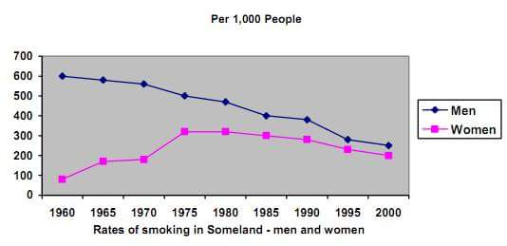

The line graph highlights the rate of smoking in Someland by both men and women over 40 years from 1960 to 2000. Male smokers were the highest in 1960 at 600 thousand and it gradually decline to a low of 300 thousand in 2000. On the other hand, the number of women smokers was the lowest in 1960 at 100 thousand and it gradually increase, peaking at 300 thousand in 1975 and eventually decreased to 200 thousand in 2000. Overall, although men were traditionally heavier smokers than women in 1960, both are smoking at almost the same rate at 250 to 300 thousand in 2000

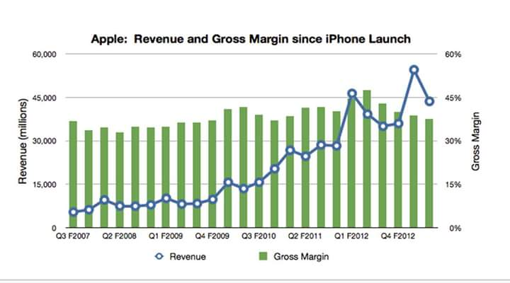

The statistical data depicts information regarding revenue gross margin from 2007 to 2012.As we can determine sales sky rocketed in 2012 up to 70,000 and in same year we can find significant decline. However, in 2007 sales hardly touched 5000.Despite with lots of ups and downs sales  had fluctuated between  2008 to 2011.In conclusion; IPhone have had turbulent sales for 4 years.

The graph shows the revenue and gross margin of apple since the launch of iphone over FY2007 to FY2012. We can see that there has been a steady rise from Q3FY2007 to Q1FY2012 when it reaches 45 Bn in revenue. After that , the revenue fluctuates for subsequent two quarters and in Q4FY2012 it again reaches the same revenue 45Bn. The gross margin was consistent in the range of 32% to 46% throughout the period.

This graph depicts Revenus & Gross Margin since Apple IPhone launch, Revenue went up unsteadly over the period of Q32007 to Q42012,In Q12012 it reached to level of 45 million revenue compare from 2008 to  20010, After that revenue flctuate for subsequent two quaters and in Q42012 it grew up & reached to the highest peak of 55 mill Despite of all up & downs in revenue gross margin consistenly in range from 30 % to 40 %through out the period.

This bar graph shows the revenue and gross margin since apple iphone launch from the year 2007 till 2012. In year 2007 q3 revenue gross margin was at 15,000 whereas it steadly increased in the year 2012q1 upto 45% as gross margin and it reached upto 55% in 2012 q4.

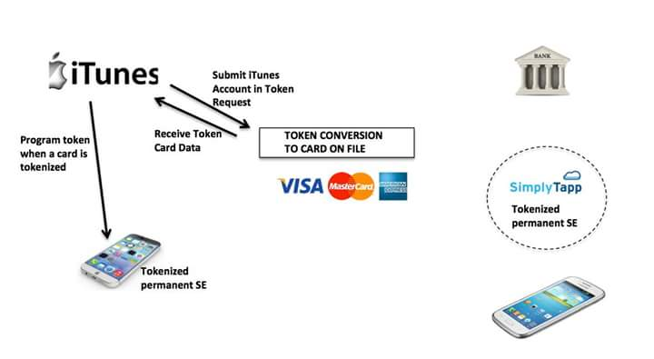

This diagram shows the process of token conversion to card file by using itunes application in iphone. Firstly submit itunes account in Token request then you will receive a card token after that itunes will program token when a card is tokenized finally tokenised SE will be recieved by itune in iphone.

This worklow expalin processing of token using iphone, first you have to submit token request using iTunes Account on receiving confirmation from your bank accout , progam will active token on you smart phone permanently

The images describes the processing of token via apple phone, first you have to submit account token  request , the request will connects to your concerned bank in last you will receive the confirmation on your same phone. Smart phone are going to have knock on effects on banks.

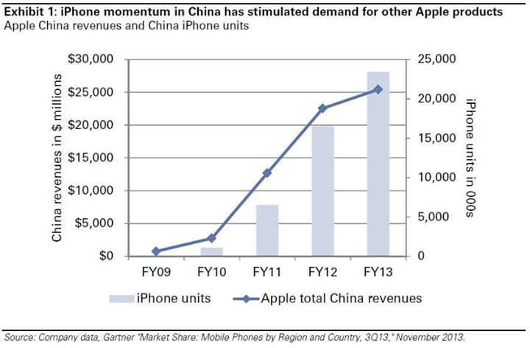

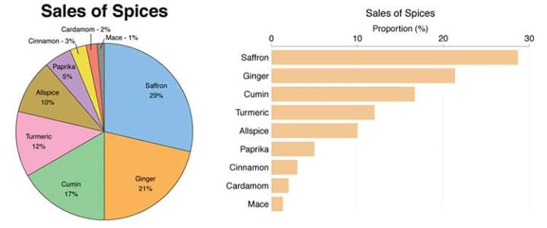This image elucidates the information about stimulated demand for other apple products due to iphone momentum in china. The bar graph nd line graph depicts the iphone units and apple total china revenues. The Maximum units sold were in FY 2013 starting from app 0 units from FY2009. The revenue also increased rapidly from FY2009 to 2013 from $0m to $25m.

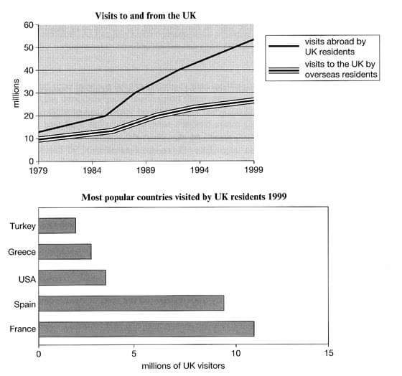The given pie chart and vertical bar graph exhibit the sales of spices in percentage. It is clearly evident that sale of saffron is 29% and closely followed by ginger 21%. Furthermore, third place retain by cumin with 17%. In addition, the bottom three places occupied by cinnamon, cardamom and mace with 3%,2%and 1% respectively . In recapitulate, we can say that saffron holds the top position among all spices in terms of sale of spices.

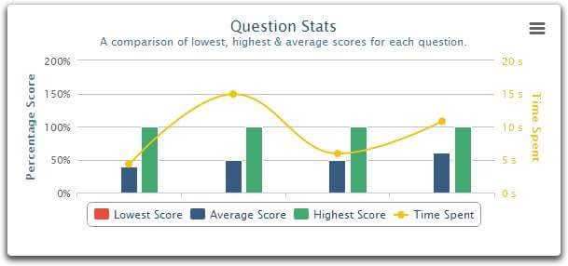The line graph elucidates the number of visitors come in England and English people travelled other countries. It is clearly seen that English people travel more than overseas resident. In 1979 more than 10 million English people travelled abroad and swelled significantly year by year and ended up more than 50 millions in 1999. On the other side, overseas people started with 10 million and increased gradually and reached to 28 millions in 1999. Moving on, vertical bar graphs depicts the favorite countries visited by English people.  It is clearly observed that first place France more than 10 millions travelled and than Spain and least travel countries  were Turkey and Greece less than 5 millions. Therefore, we can say that France is the favorite  country for UK residents  among other countries.

The graph depicts the comparison of lowest, highest and average scores for each questions and its relevant time spent of them. It is quite apparent that there was no lowest score recorded for any question and all the average score for each question has same taken the same amount of time, i.e., around 5 sec , however for highest score the time spent on each question is not more than 10 sec.............Akeel please suggest.

the picute shows the question statistics which is basically a comparison of lowest, highest nd average scores for each question. We can see that on in order to score average the amount of time spent is 5s or 50%.. and for highest score the amount of time spent is 10s or 100%.. it shows that if someone wants highest score, they must give time and read the question properly

This graph precisely shows that, for first average question takes minimum time around 5 seconds, however, these trends changed from other questions to the average scored questions. Besides, the highest score questions are spent maximum time was 7 Sec and it varies from one to another. In and all, noticeably, shows the lowest scores not spent any time.

This graph shows the comparison of time spend for lowest,average and highest score for 4 different questions. It can be clearly seen that, none of the students scored lowest score for any of the questions and the second question is the most time consuming question among all questions. However, question no 1 and no 3 were not took more than 6 seconds to complete where as highest score students took around 8 seconds to complete question 1. Average score students consumed around 10 secs to complete question 4. In conclusion, it cabe said that question 2 and question 4 are much harder than other two questions.

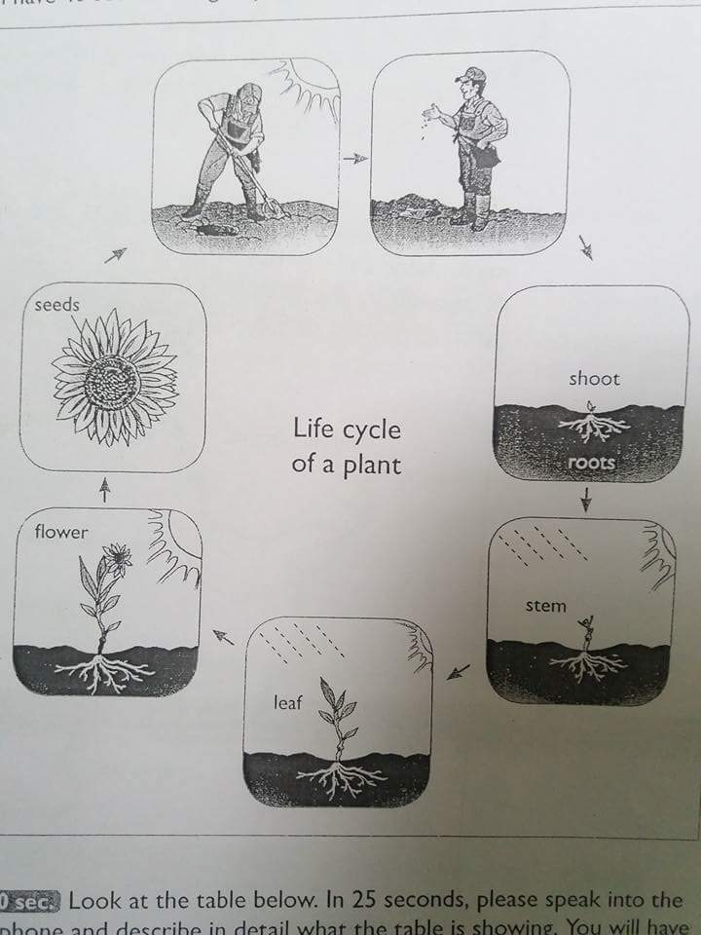The image describes about the "Life cycle of plant”. It consists of 6 seven steps. The beginning started by human plantation seed on earth, following into shoot-steam-leaf and in last as flower and cycle continues with seeds again.

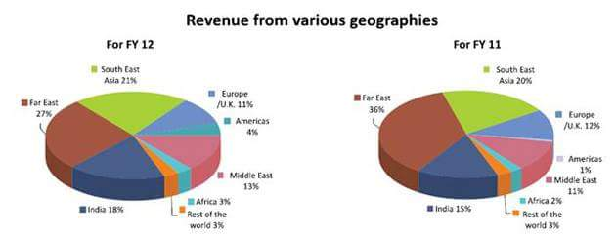

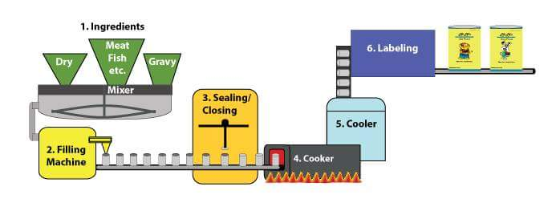The diagram compares the Revenues of two financial years from various geographies.The top contributor is Far East in both FY11 and FY12 with slight decrease in FY12 from 36% to 27%. South East and India stood at 2nd and 3rd positions respectively in both the years with former increasing from 20% to 21% and latter from 15% to 18%. Africa stood as one of the least contributors in both the years

This diagram illustrates the process of ready to eat food preparation.It is immediately apprent that, there are 6 steps.Intially raw materials get mixed and then pass to the filling machine following with sealing of lid.Once sealed these can go to cooker for cooking that makes it edible.Finally after cooling and lebeling, cans are ready to dispatch.

PTE Academic Describe Image Tips

**#1. Be familiar with types of image**

There is a few kind of images that may appear for this section, so you need to get yourself familiar with it hence you will not go panic even if you encounter one. Imagine going for the same movie again and again, boring huh? ok, that's not what I mean. What I mean is learning to expect the type of movies you are going to watch, so it would be worthwhile for your money and, of course, your precious time.   
  
During the test, do not be surprised if you encounter a picture, line graph, bar graph, pie chart, map, table,  process graph, and even Venn diagram. If you do get something new, let me know in the comment section.

A picture:

[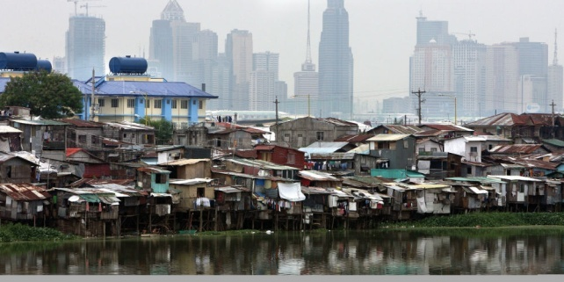](http://newsinfo.inquirer.net/files/2012/08/floodway-banks.jpg)

Bar graph:

[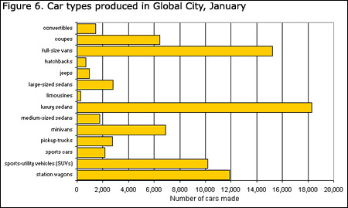](http://www.statcan.gc.ca/edu/power-pouvoir/ch9/img/5214818_06-eng.jpg)

Pie chart:

[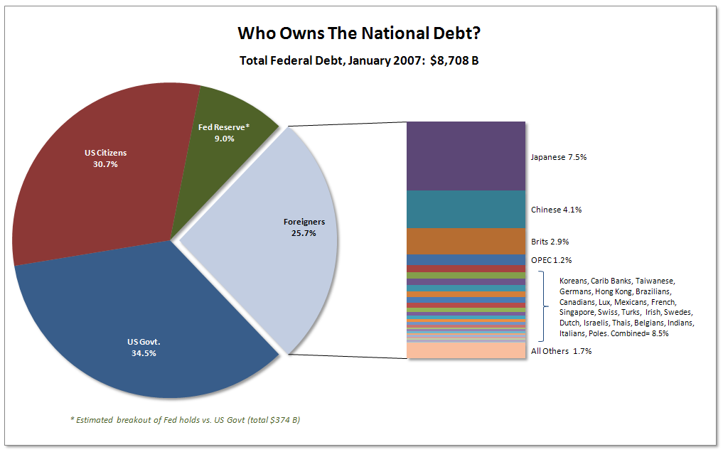](http://j-walkblog.com/images/piechartalternative2.png)

Map

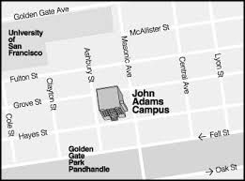

Table

[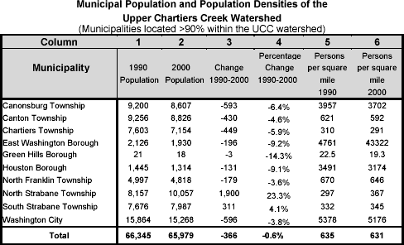](http://www.upperchartierscreek.org/images/population_table.gif)

Process graph

[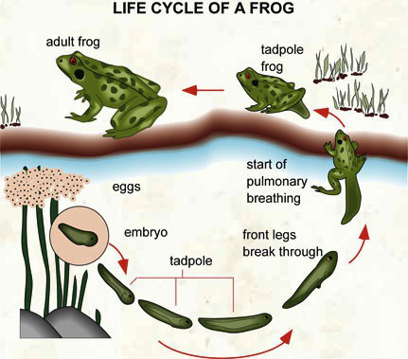](http://i1.wp.com/ieltsliz.com/wp-content/uploads/2014/11/froglifecycle.jpg)

Venn diagram

[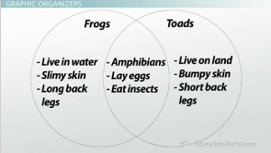](http://study.com/cimages/multimages/16/venn-diagram-example.jpg)

**#2. Get yourself a framework**

You can use below framework when describing an image. Remember you only have 40 seconds to speak, so make use of it and do not speak beyond the timing. Otherwise, the system would mark your answer as incomplete.   
  
What you need to speak about:  
A. Overview  
The chart shows the future trends in the percentage of American citizens over 65 years old.  
  
B. Point 1  
In 2010, about 13 percent of US citizens were over 65. This figure is predicted to rise steadily so that by 2035, it will be 20 percent.  
  
C. Point 2:   
Between 2010 and 2030, the rise will be quite steady whereas between 2030 and 2035, the rise is less significant. – suggesting that the increase in the aging population may peak shortly after 2035.  
  
D. Conclusion/Prediction.  
However, the rise will have serious implications in areas such as the provision of government services.  
  
Often the image will have too many details, do not get yourself overwhelmed by this, you only need to identify two points and you can ignore the rest.   
Keep in mind that the test is not designed for you to speak about all the details, it is not possible in such short period of time.

**#3. Practice, review, repeat**

My last tip would be a simple one, keep your smartphone ready, then record your answer and review. Make sure you have finished your last sentence before it hit the 40-seconds mark, aim for 38-39 seconds.  
  
Good luck!

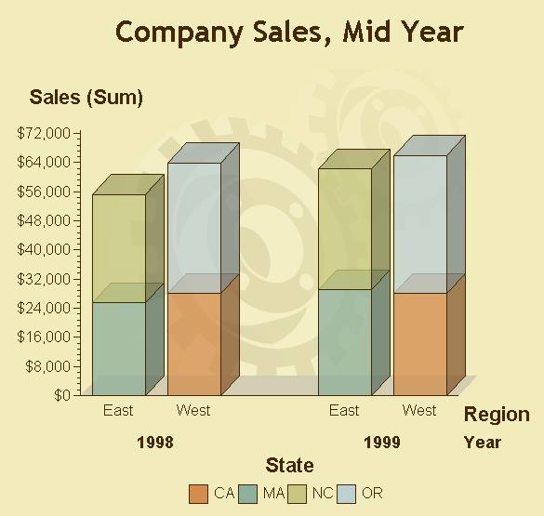

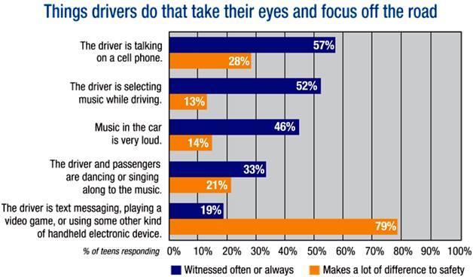

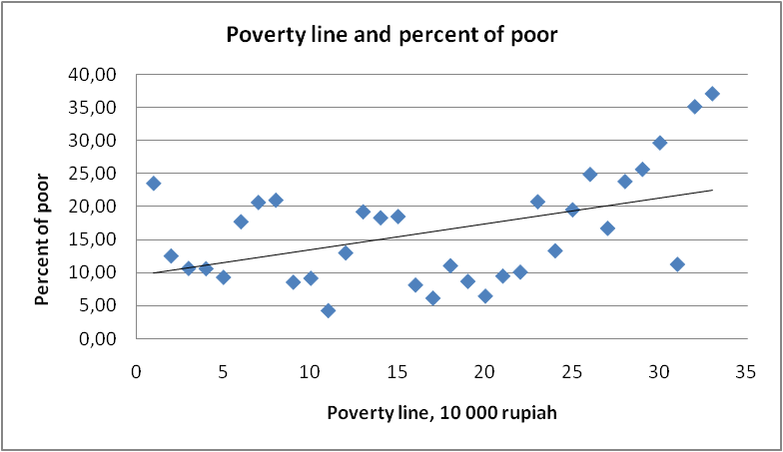

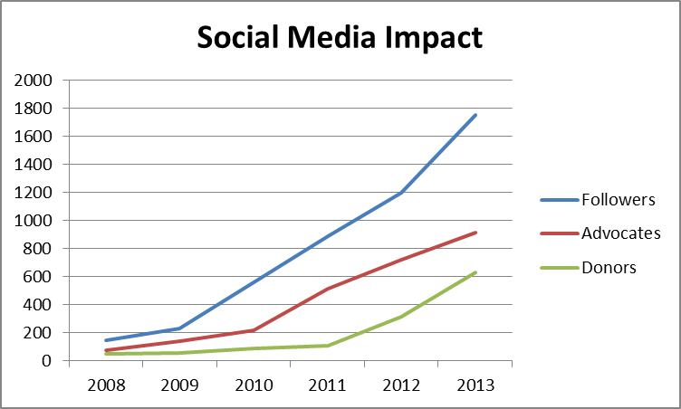

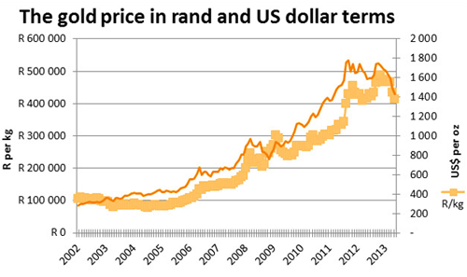

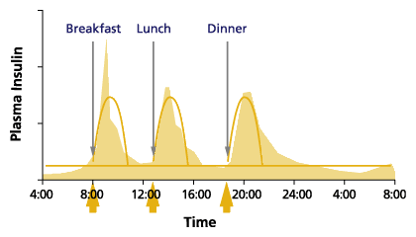

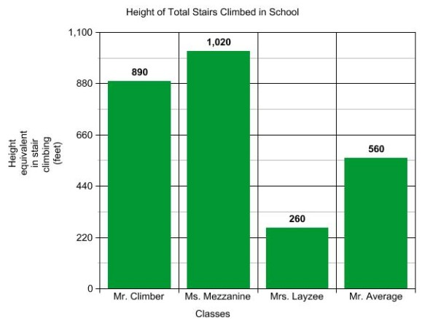

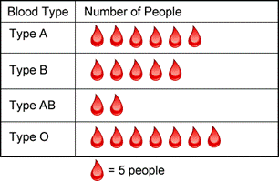

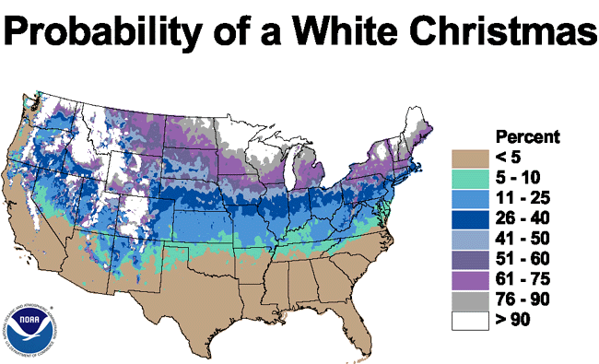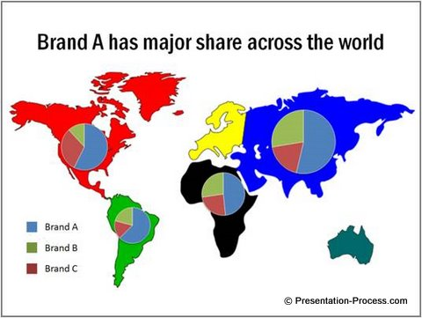

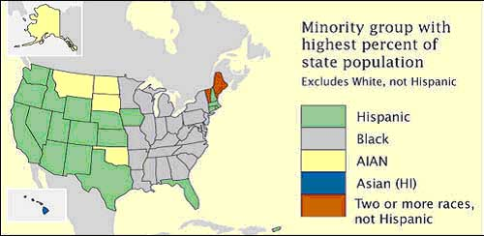

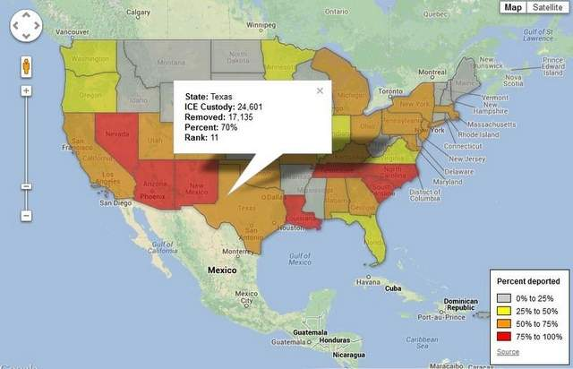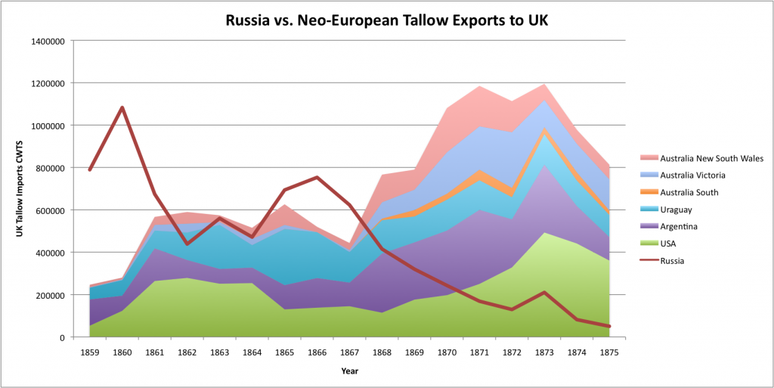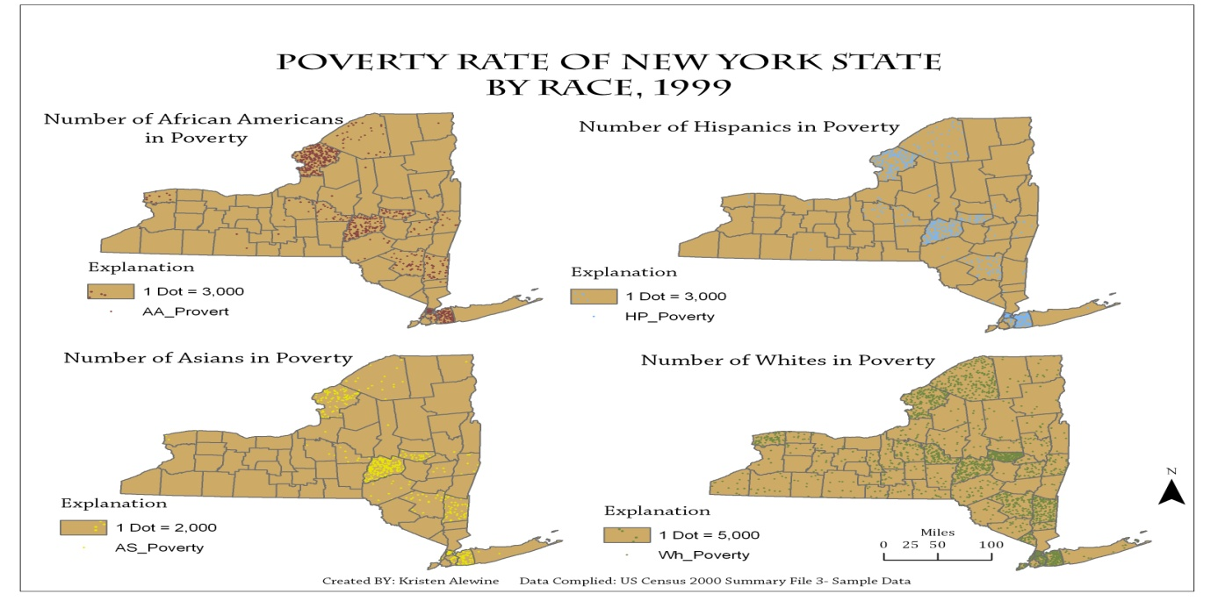

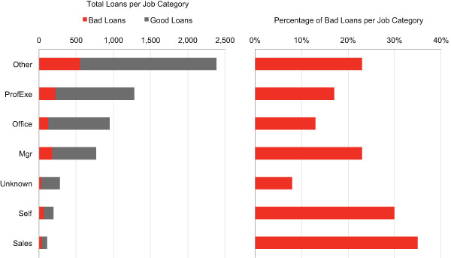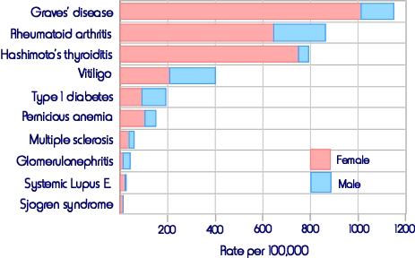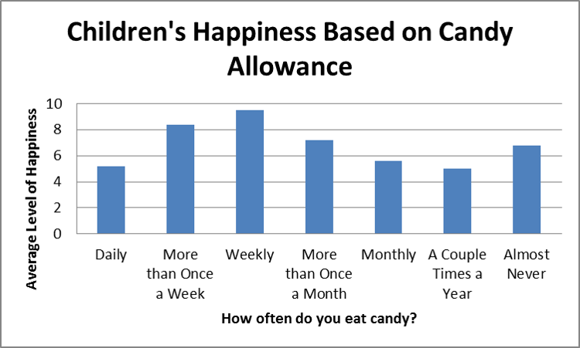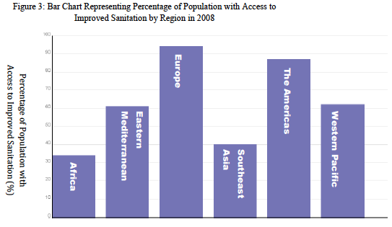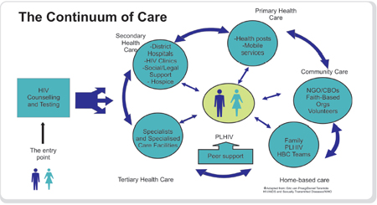

1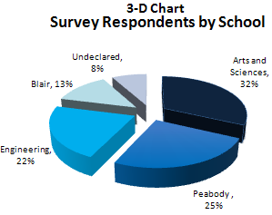 2 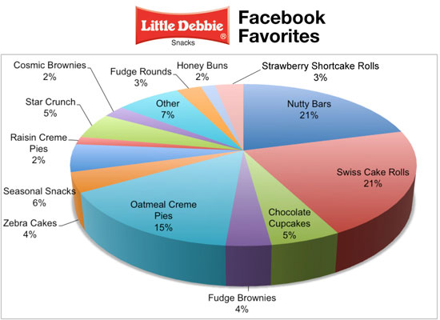

3

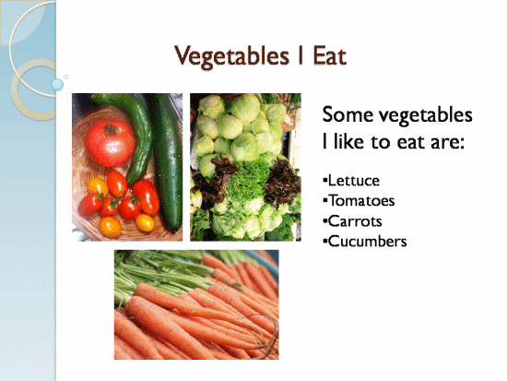 4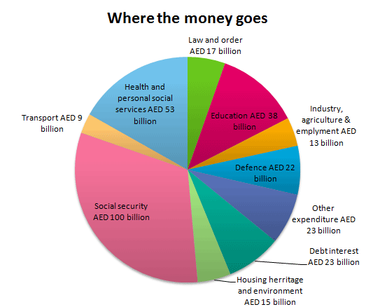

5

6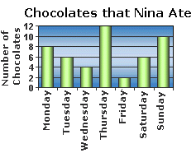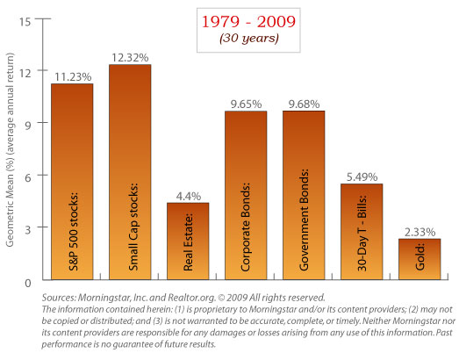 7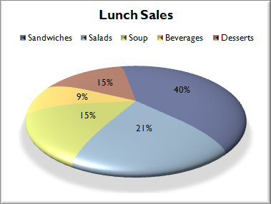

8 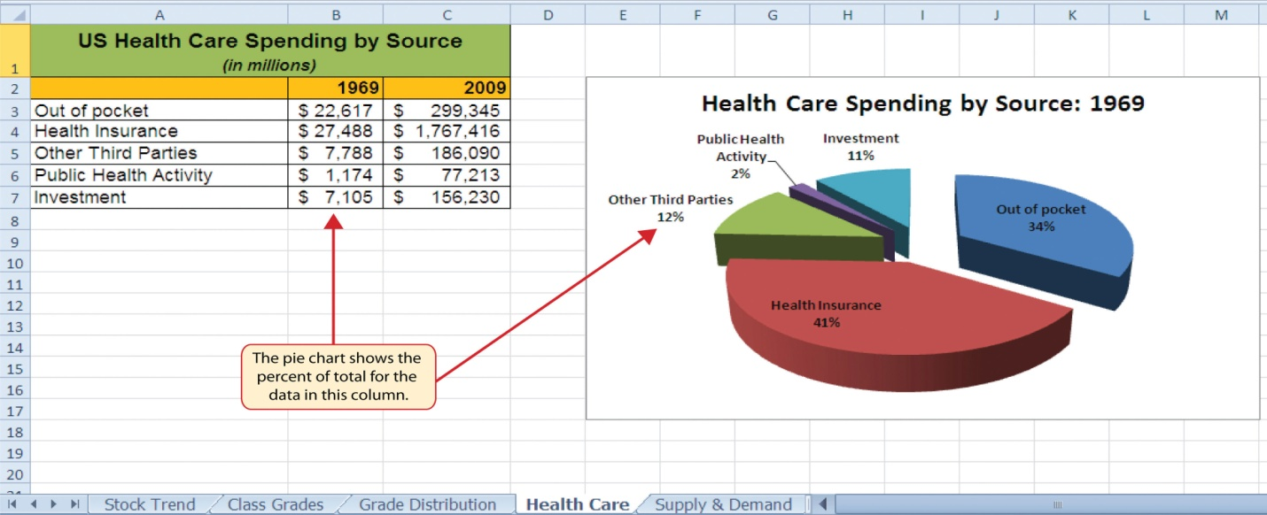

9

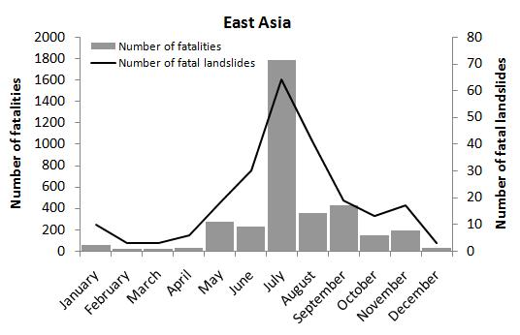

10

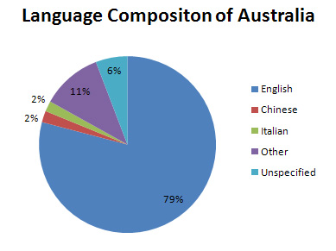

11

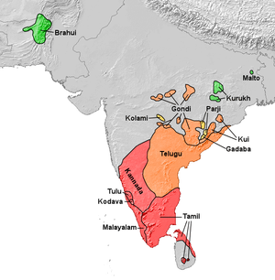

12

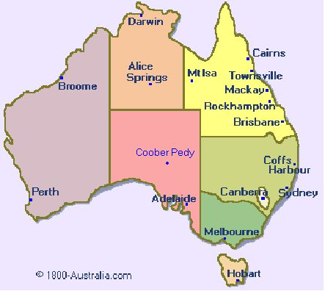

13

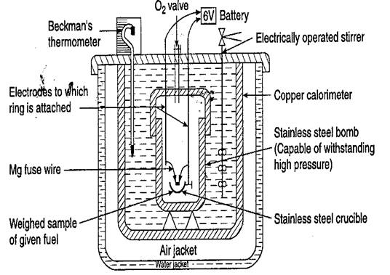

14

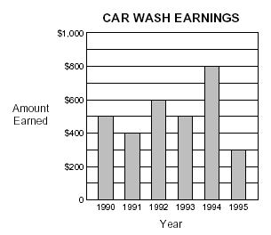

15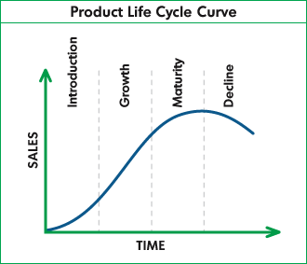

16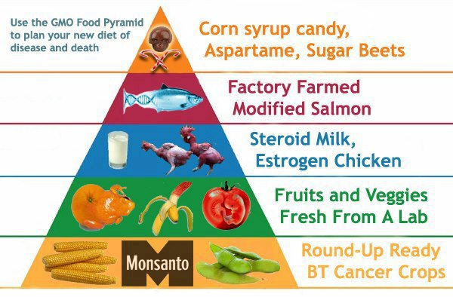

17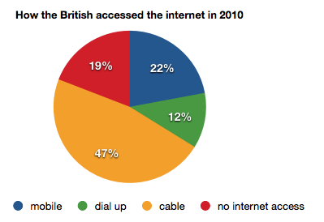

18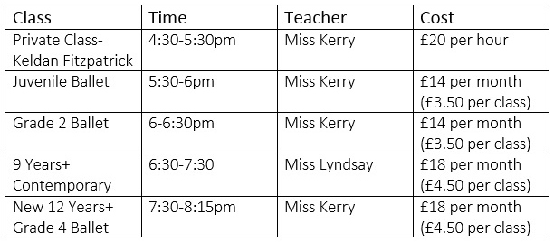

19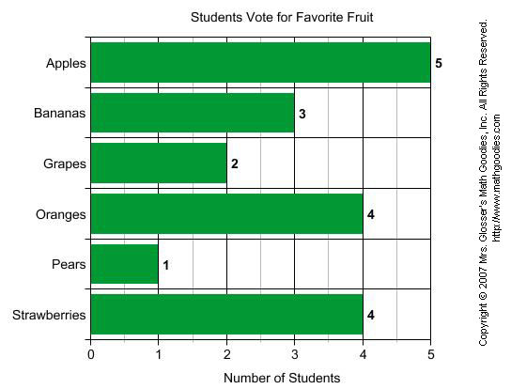 20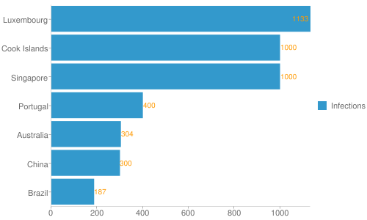

21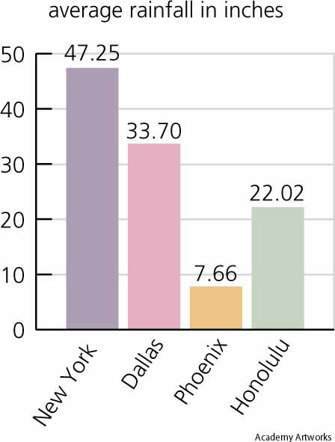

22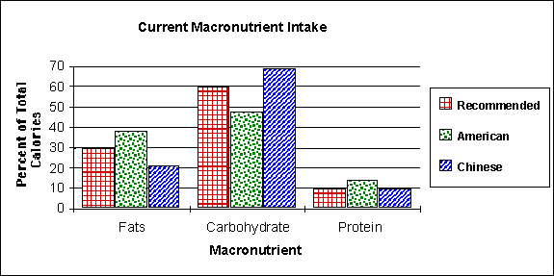

23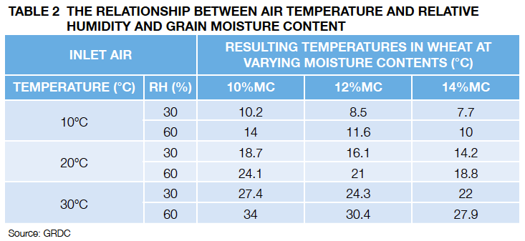

23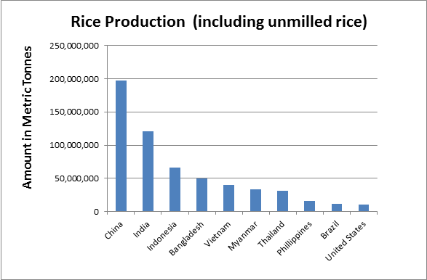

24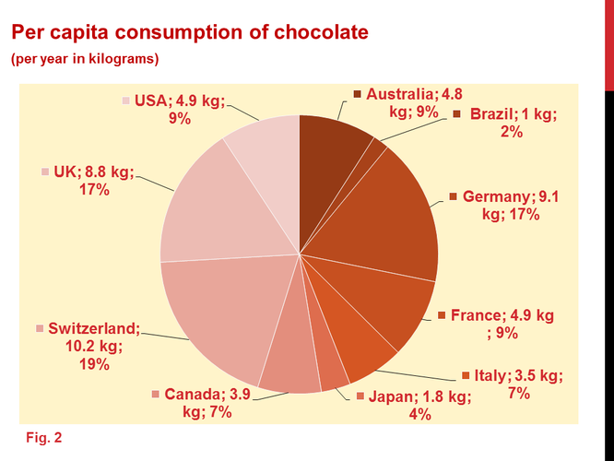

24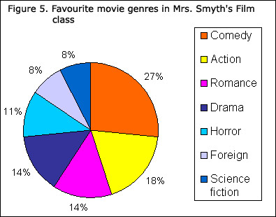

25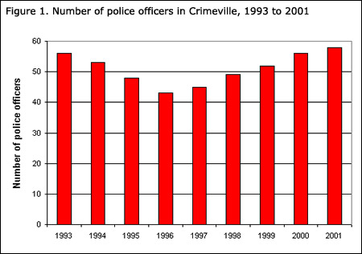

26

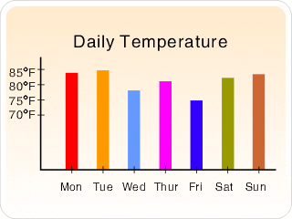

27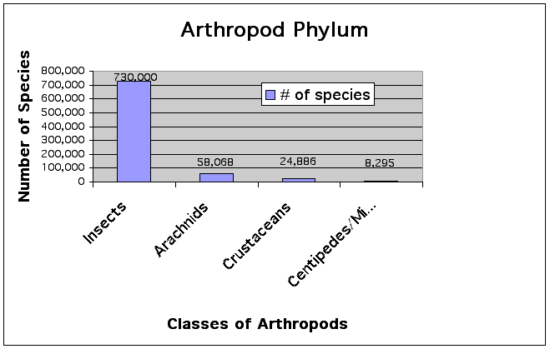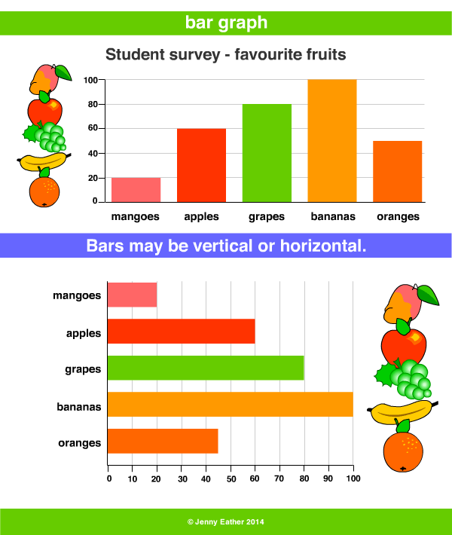

28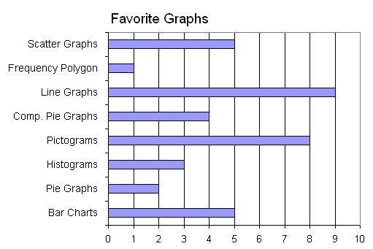

29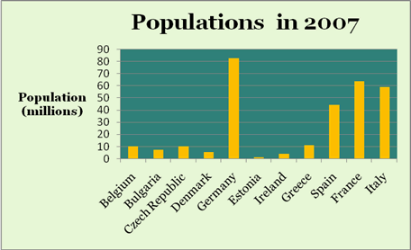

30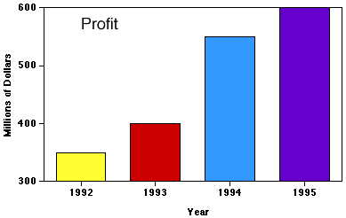

31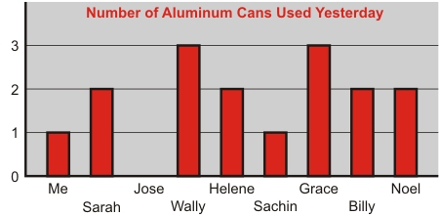

32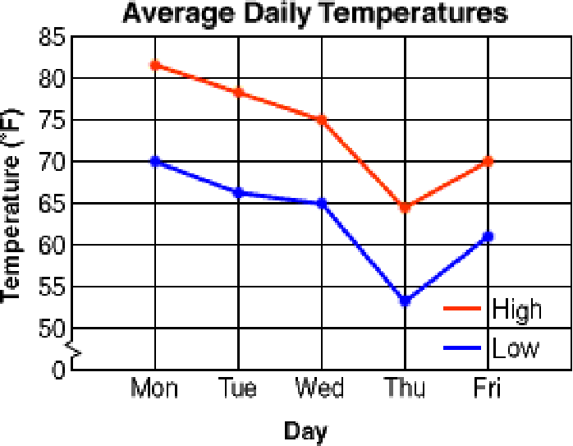

33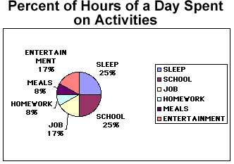

34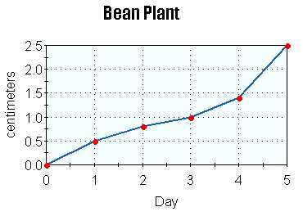

36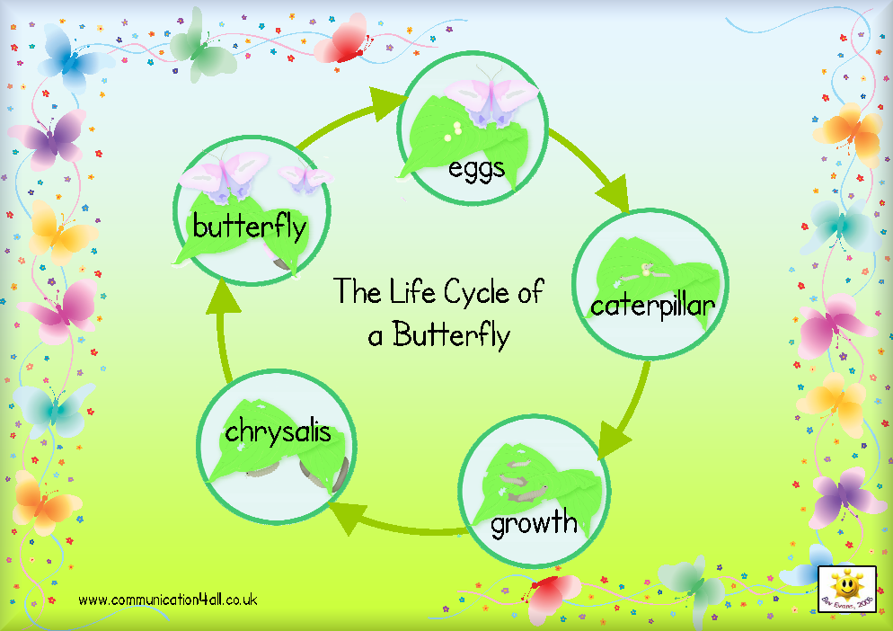

37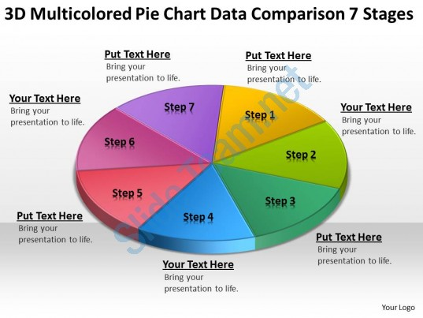

38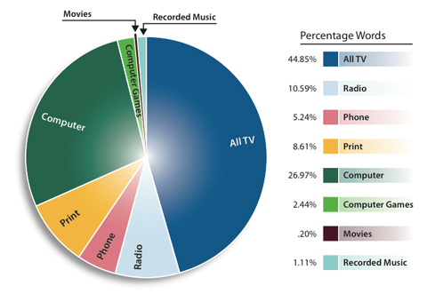

39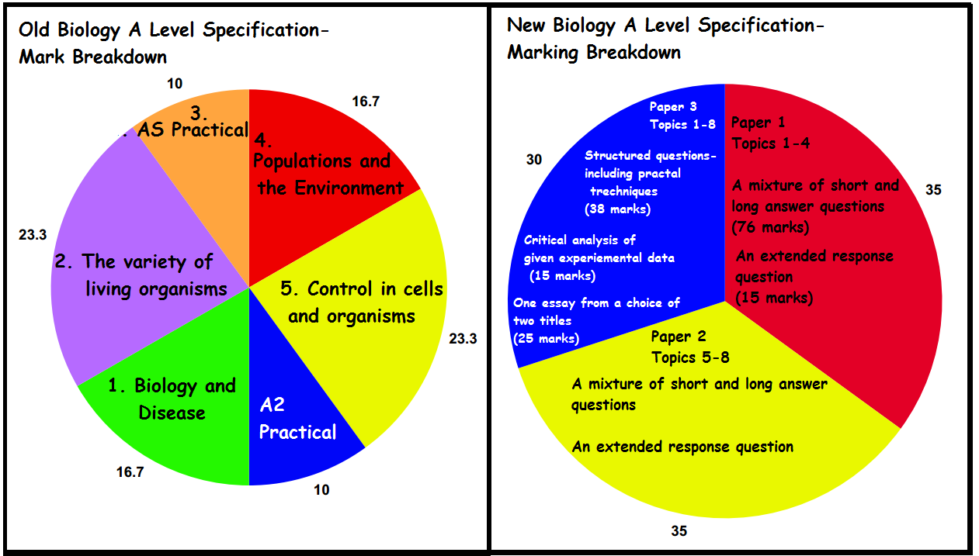40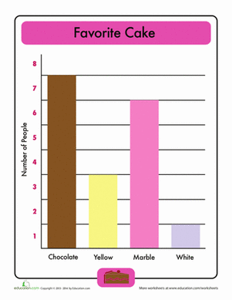

41

42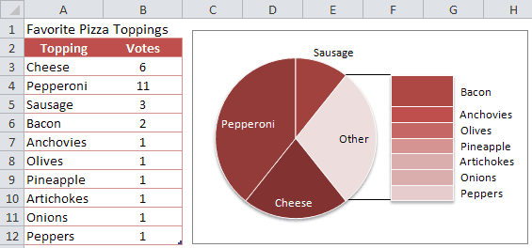

43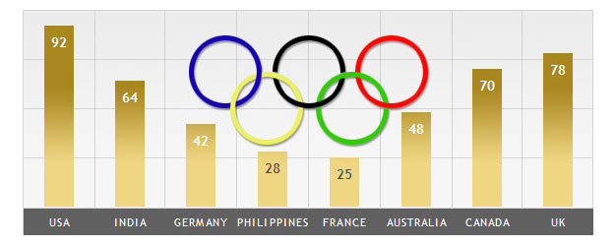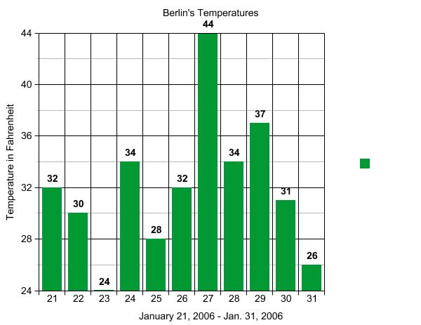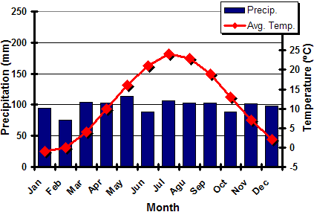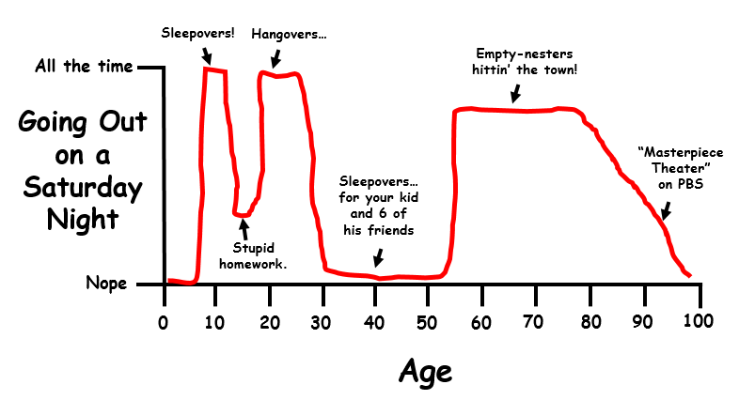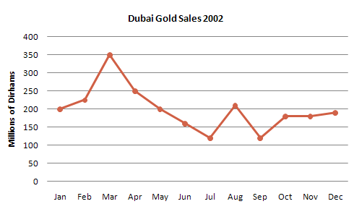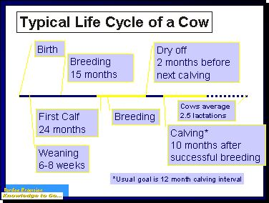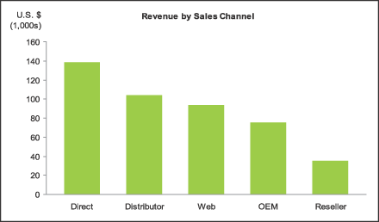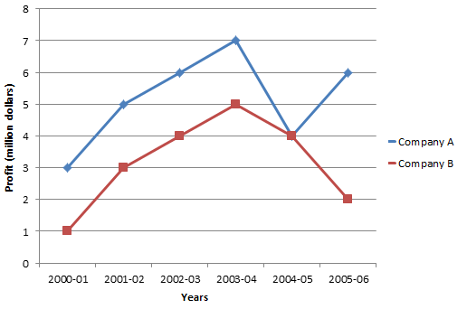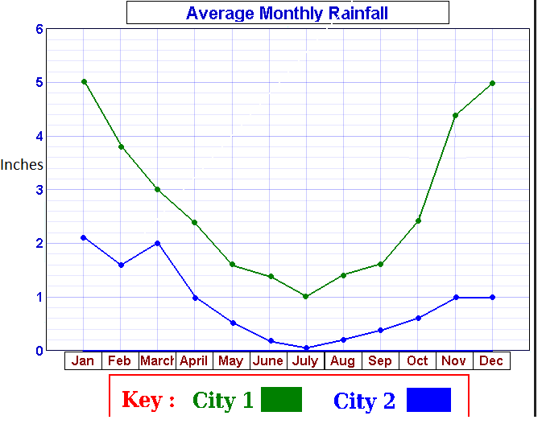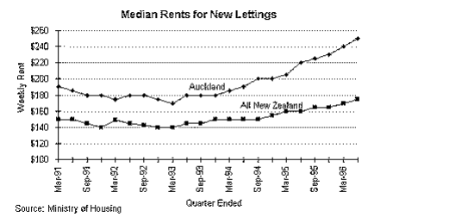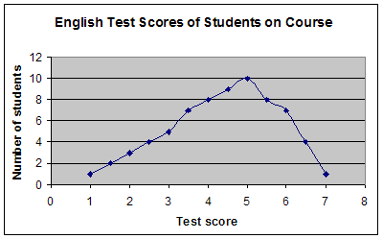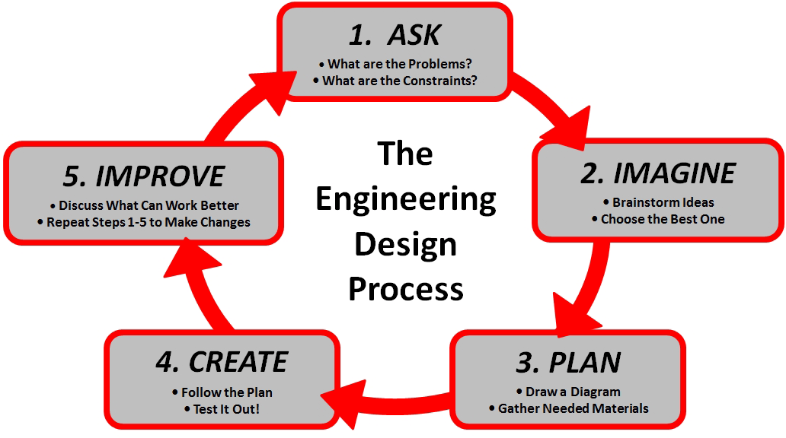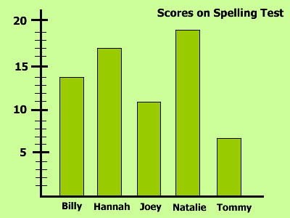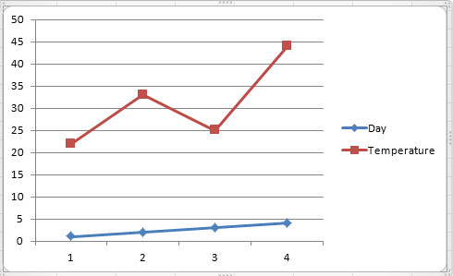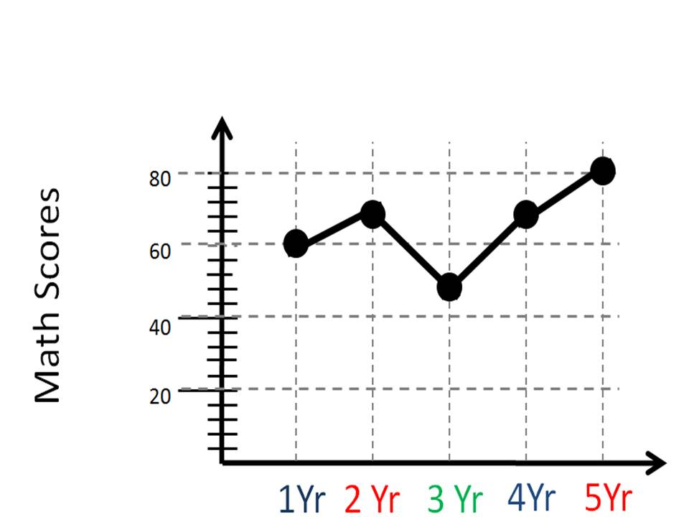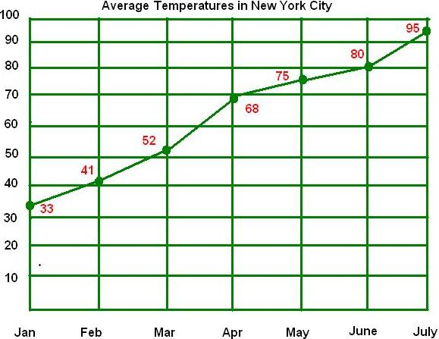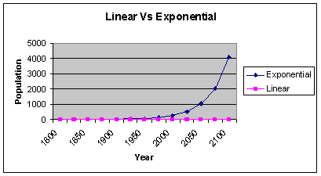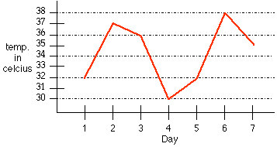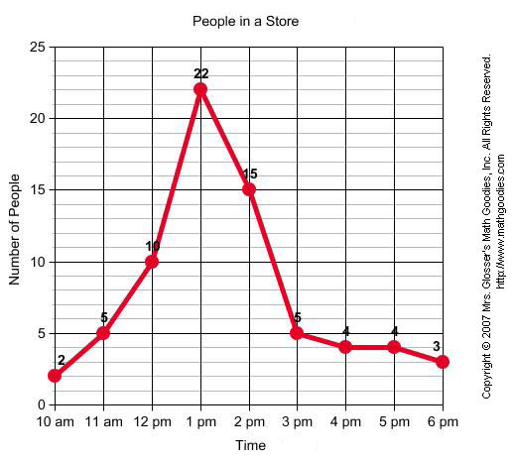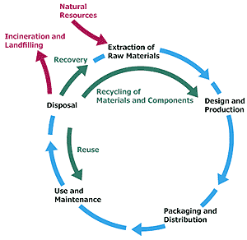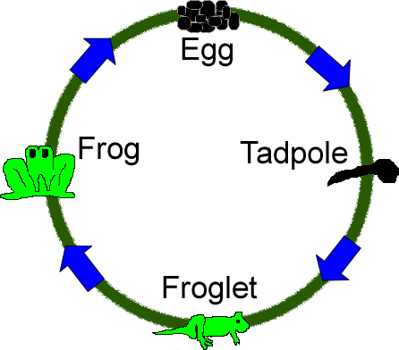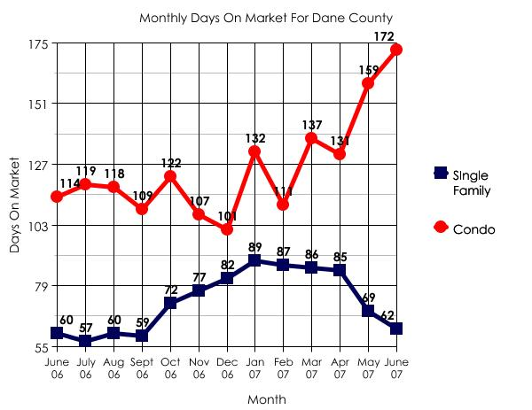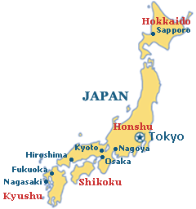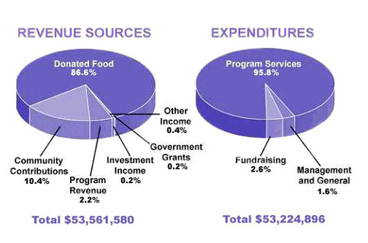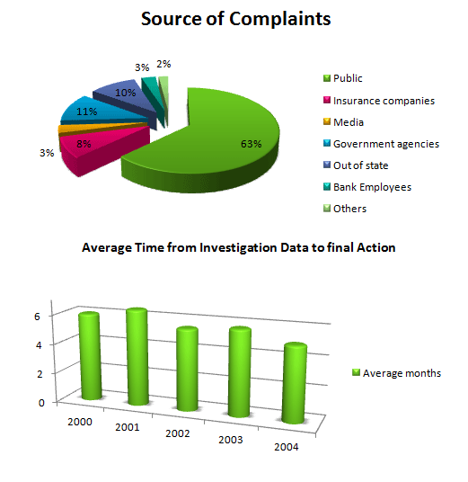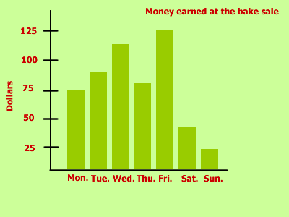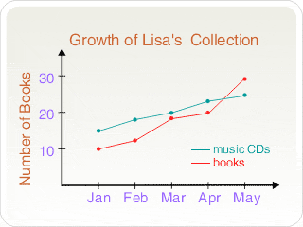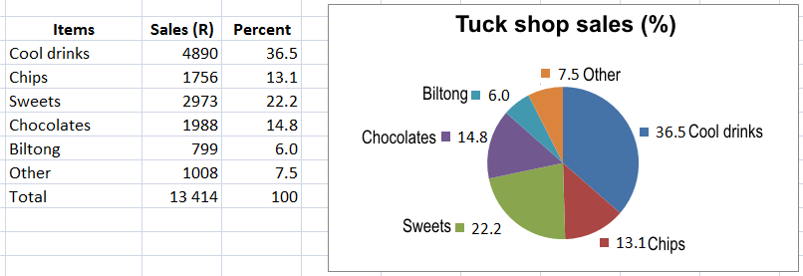

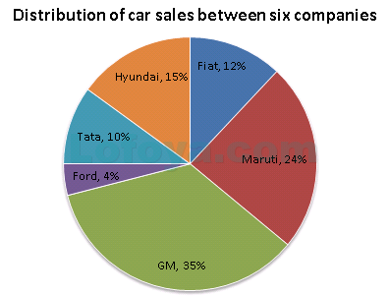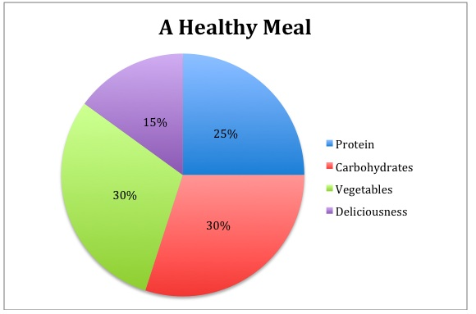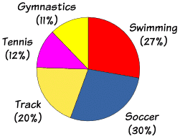

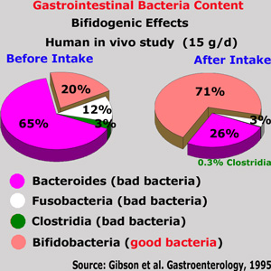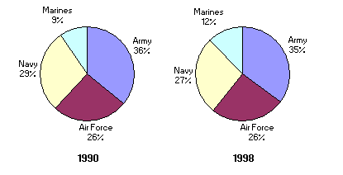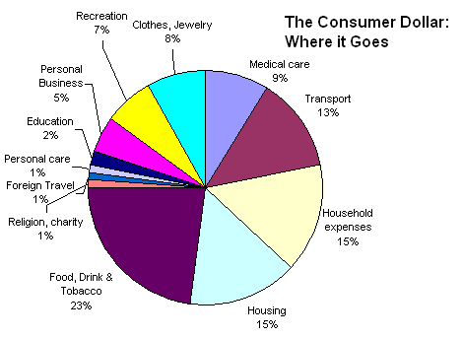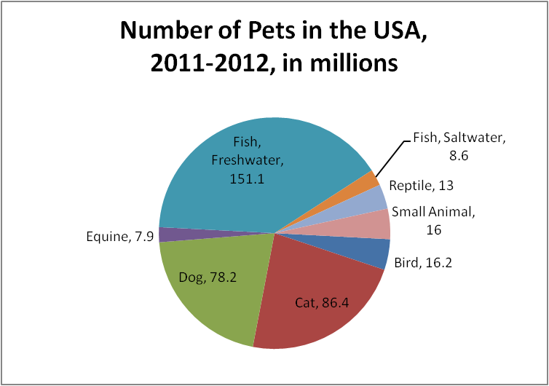 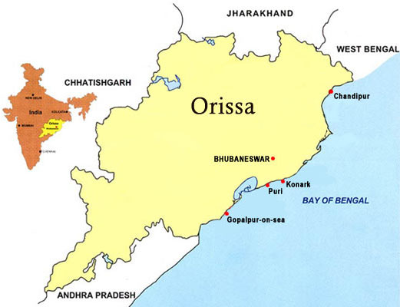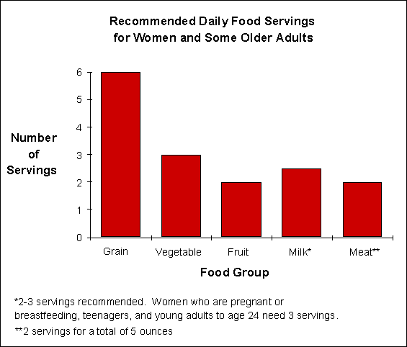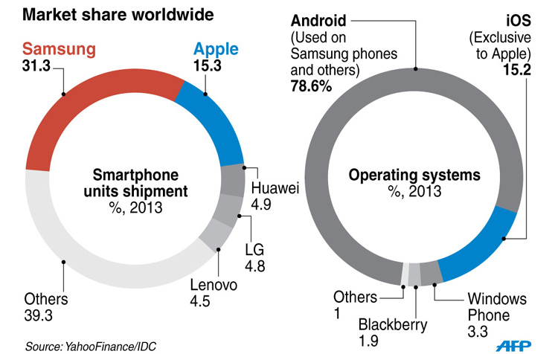 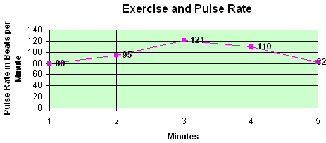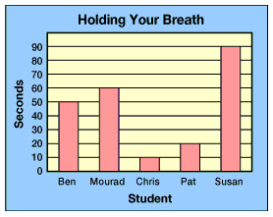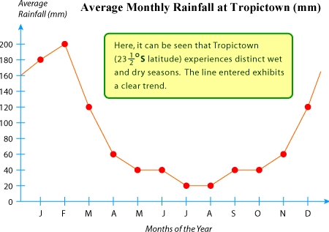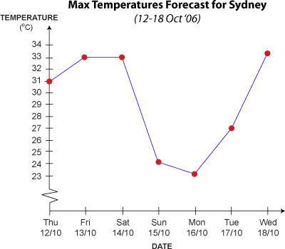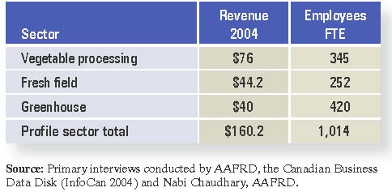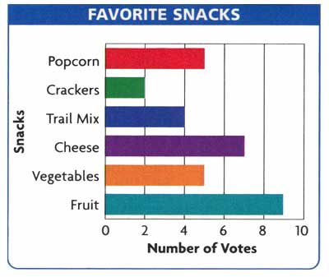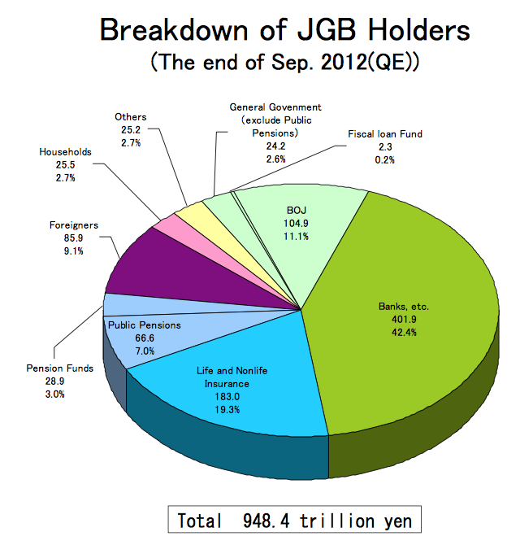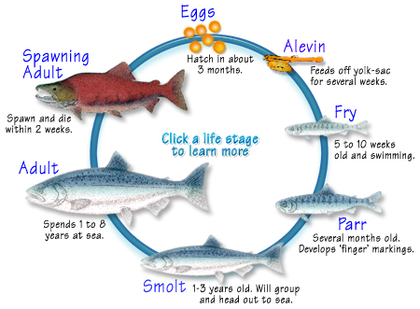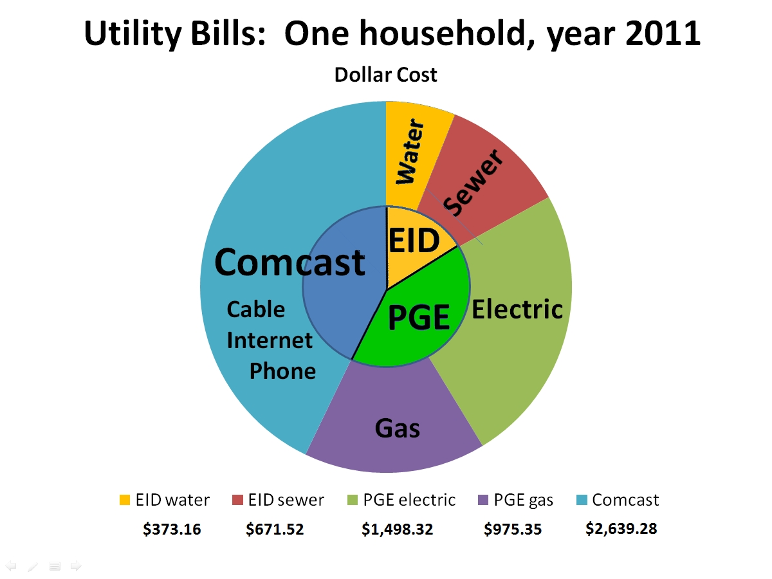

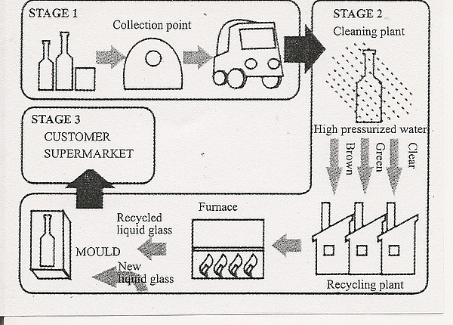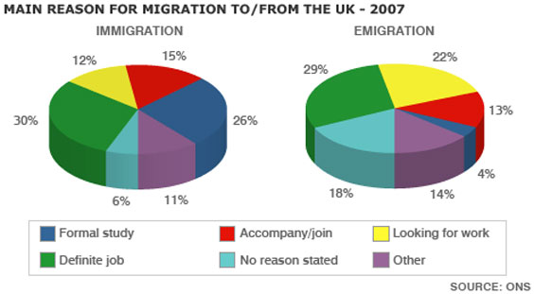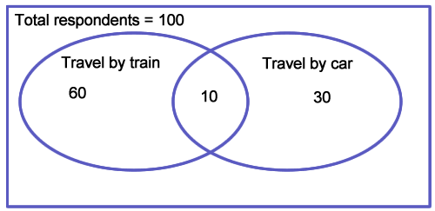

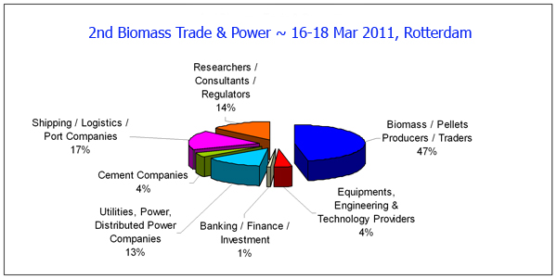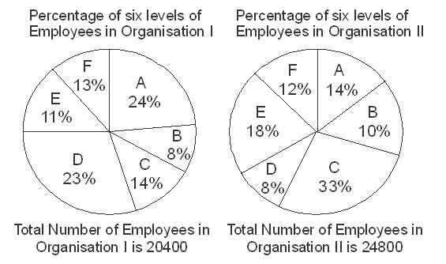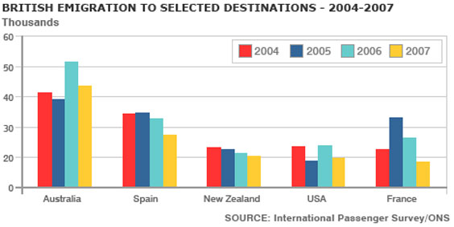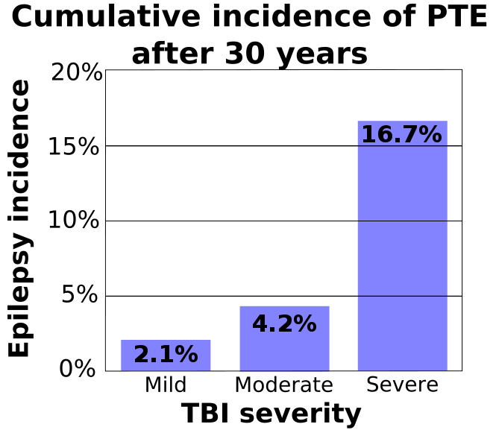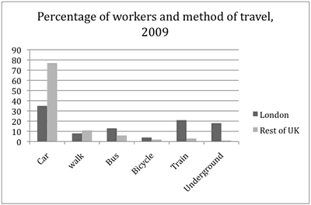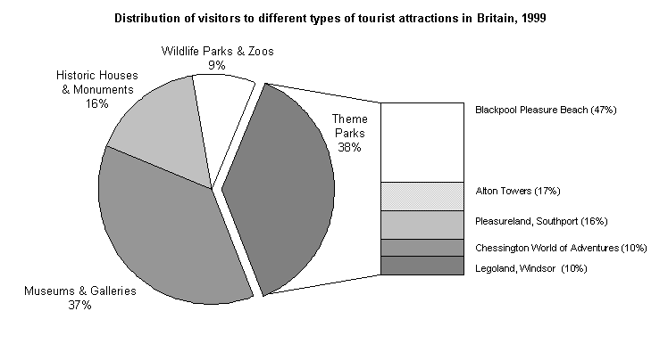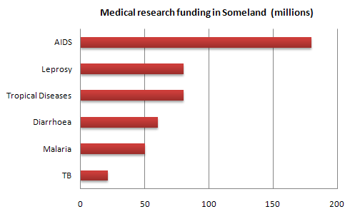d